

**SYSTEM PROVISIONING AND CONFIGURATION MANAGEMENT**

**LAB**

YEAR: 2024

NAME: Aastha Mishra

SAP ID: 500094912

ROLL NO: R2142210013

COURSE: BTech CSE (DevOps)

SEMESTER: Sixth (B3)

FACULTY NAME: Dr.Hitesh Kumar Sharma

# Lab Exercise 7– Creating Multiple IAM Users in Terraform

**Objective:**

Learn how to use Terraform to create multiple IAM users with unique settings.

# Prerequisites:

* Terraform installed on your machine.
* AWS CLI configured with the necessary credentials.

# Steps:

1. **Create a Terraform Directory:**

**mkdir terraform-iam-users cd terraform-iam-users**

* Create Terraform Configuration Files:
* Create a file named main.tf:

## # main.tf

**provider "aws" { region = "us-east-1"**

**}**

**variable "iam_users" { type = list(string)**

**default = ["user1", "user2", "user3"]**

**}**

**resource "aws_iam_user" "iam_users" { count = length(var.iam_users)**

**name = var.iam_users[count.index]**

**tags = {**

**Name = "${var.iam_users[count.index]}-user"**

**}**

**}**

In this configuration, we define a list variable iam_users containing the names of the IAM users we want to create. The aws_iam_user resource is then used in a loop to create users based on the values in the list.

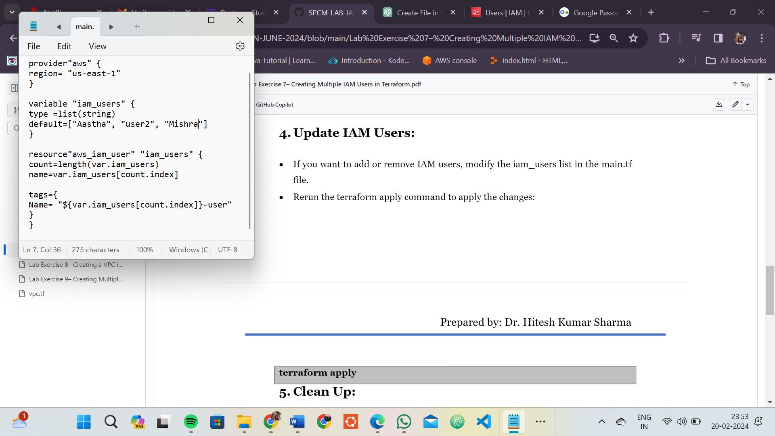

# Initialize and Apply:

Run the following Terraform commands to initialize and apply the configuration:

**terraform init terraform apply**

Terraform will prompt you to confirm the creation of IAM users. Type yes and press Enter.

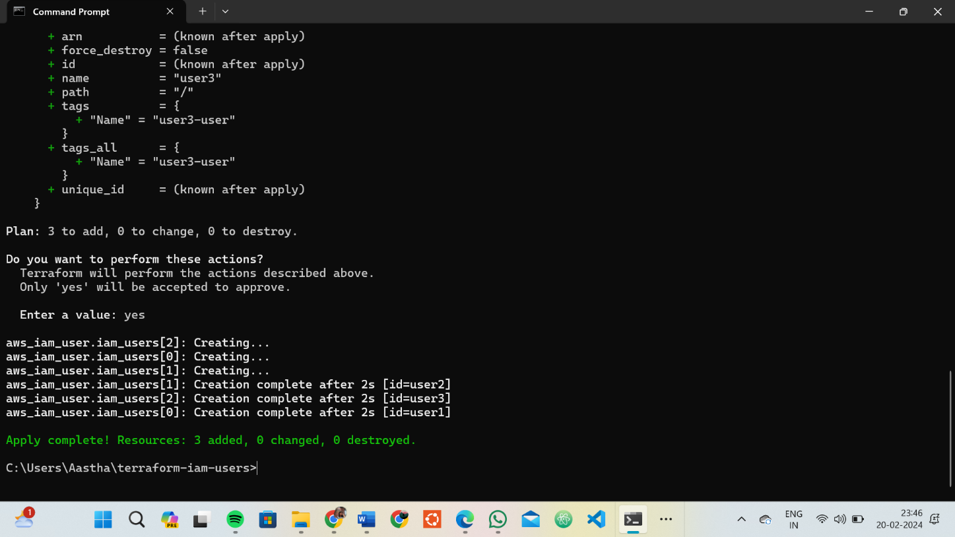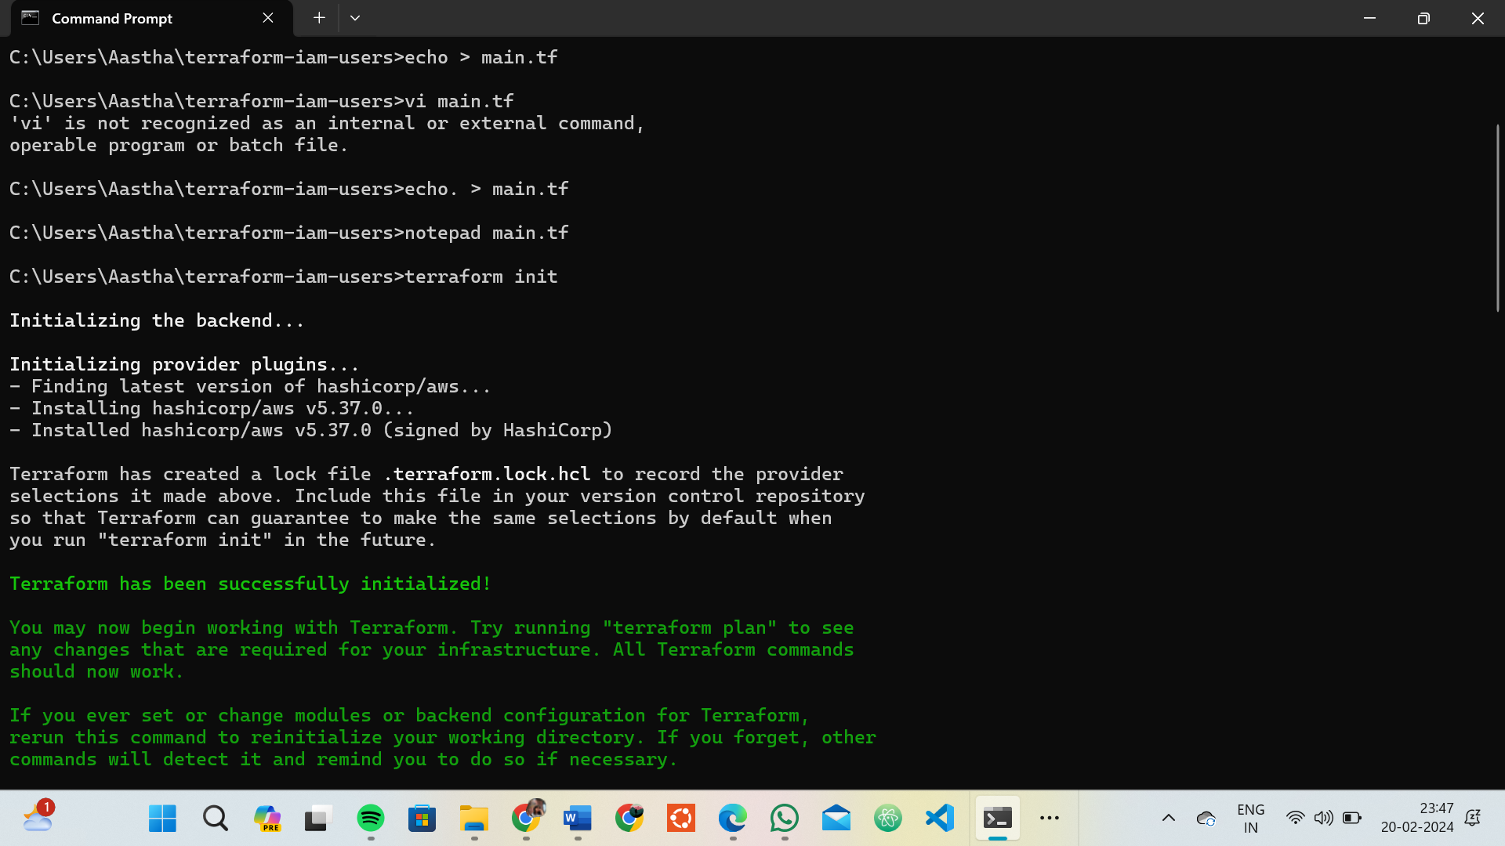

# Verify Users in AWS Console:

* Log in to the AWS Management Console and navigate to the IAM service.
* Verify that the IAM users with the specified names and tags have been created.

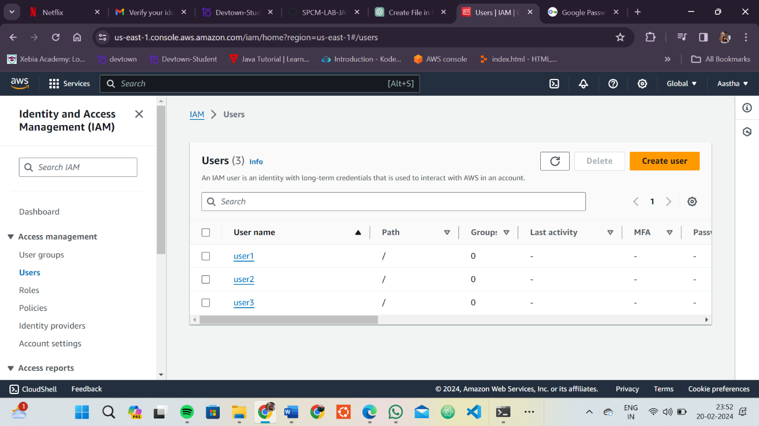

# Clean Up:

* After testing, you can clean up the IAM users:

**terraform destroy**

* Confirm the destruction by typing yes.

# Conclusion:

This lab exercise demonstrates how to create multiple IAM users in AWS using Terraform. The use of variables and loops allows you to easily manage and scale the creation of IAM users. Experiment with different user names and settings in the main.tf file to understand how Terraform provisions resources based on your configuration.

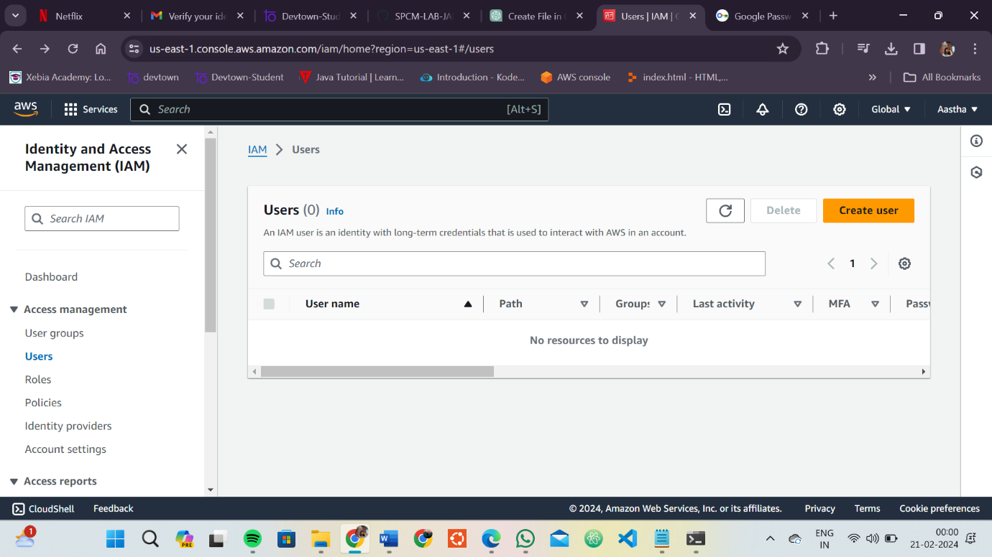

# Lab Exercise 8– Creating a VPC in Terraform Objective: Objective:

Learn how to use Terraform to create a basic Virtual Private Cloud (VPC) in AWS.

# Prerequisites:

* Terraform installed on your machine.
* AWS CLI configured with the necessary credentials.

# Steps:

1. **Create a Terraform Directory:**

**mkdir terraform-vpc cd terraform-vpc**

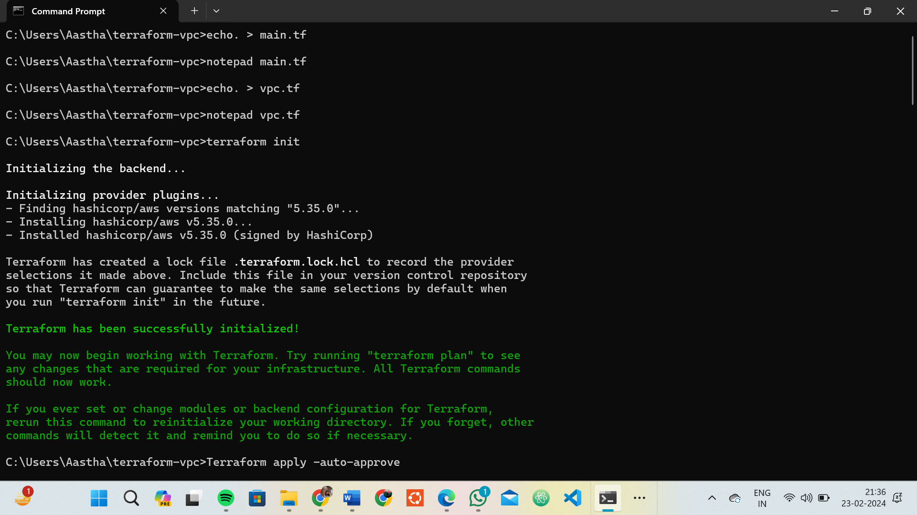

* Create Terraform Configuration Files:
* Create a file named main.tf: # main.tf

**provider "aws" { region = "us-east-1"**

**}**

**resource "aws_vpc" "my_vpc" { cidr_block = "10.0.0.0/16" enable_dns_support = true enable_dns_hostnames = true**

**tags = {**

**Name = "MyVPC"**

**}**

**}**

**resource "aws_subnet" "my_subnet" {**

**count = 2**

**vpc_id**

**cidr_block**

**= aws_vpc.my_vpc.id**

**= "10.0.${count.index + 1}.0/24"**

**availability_zone = "us-east-1a"**

**map_public_ip_on_launch = true**

**tags = {**

**Name = "MySubnet-${count.index + 1}"**

**}**

**}**

In this configuration, we define an AWS provider, a VPC with a specified CIDR block, and two subnets within the VPC.

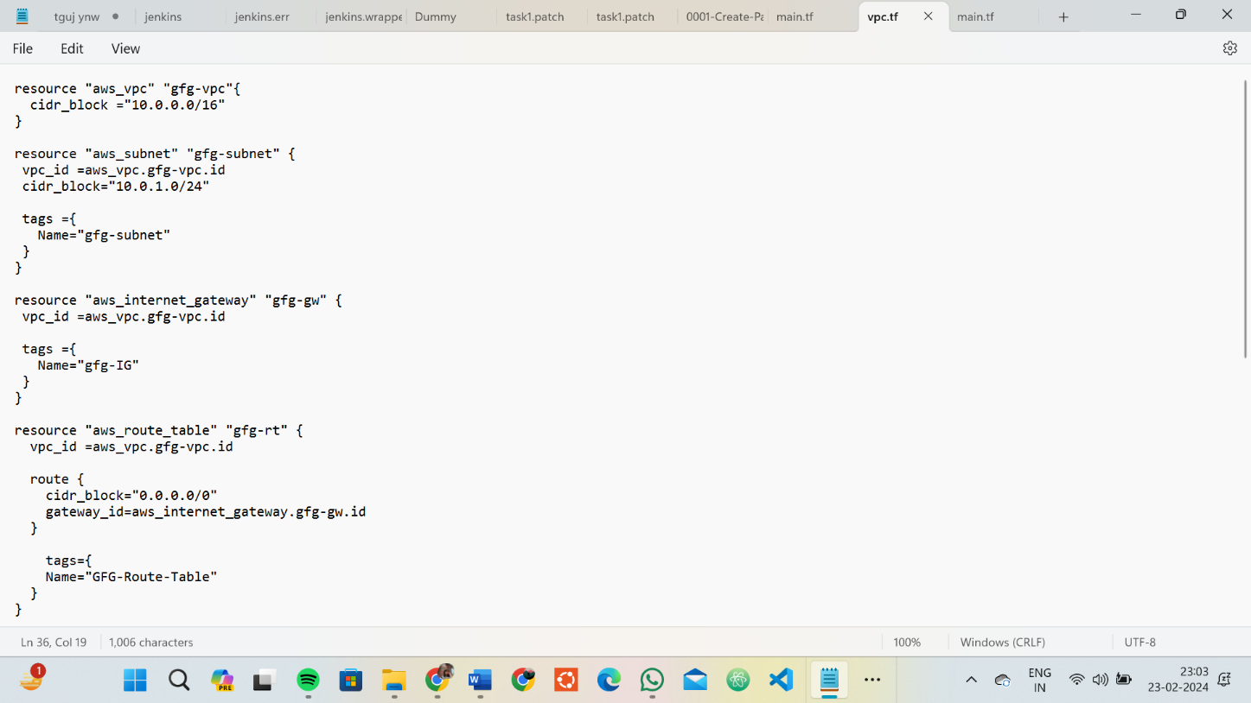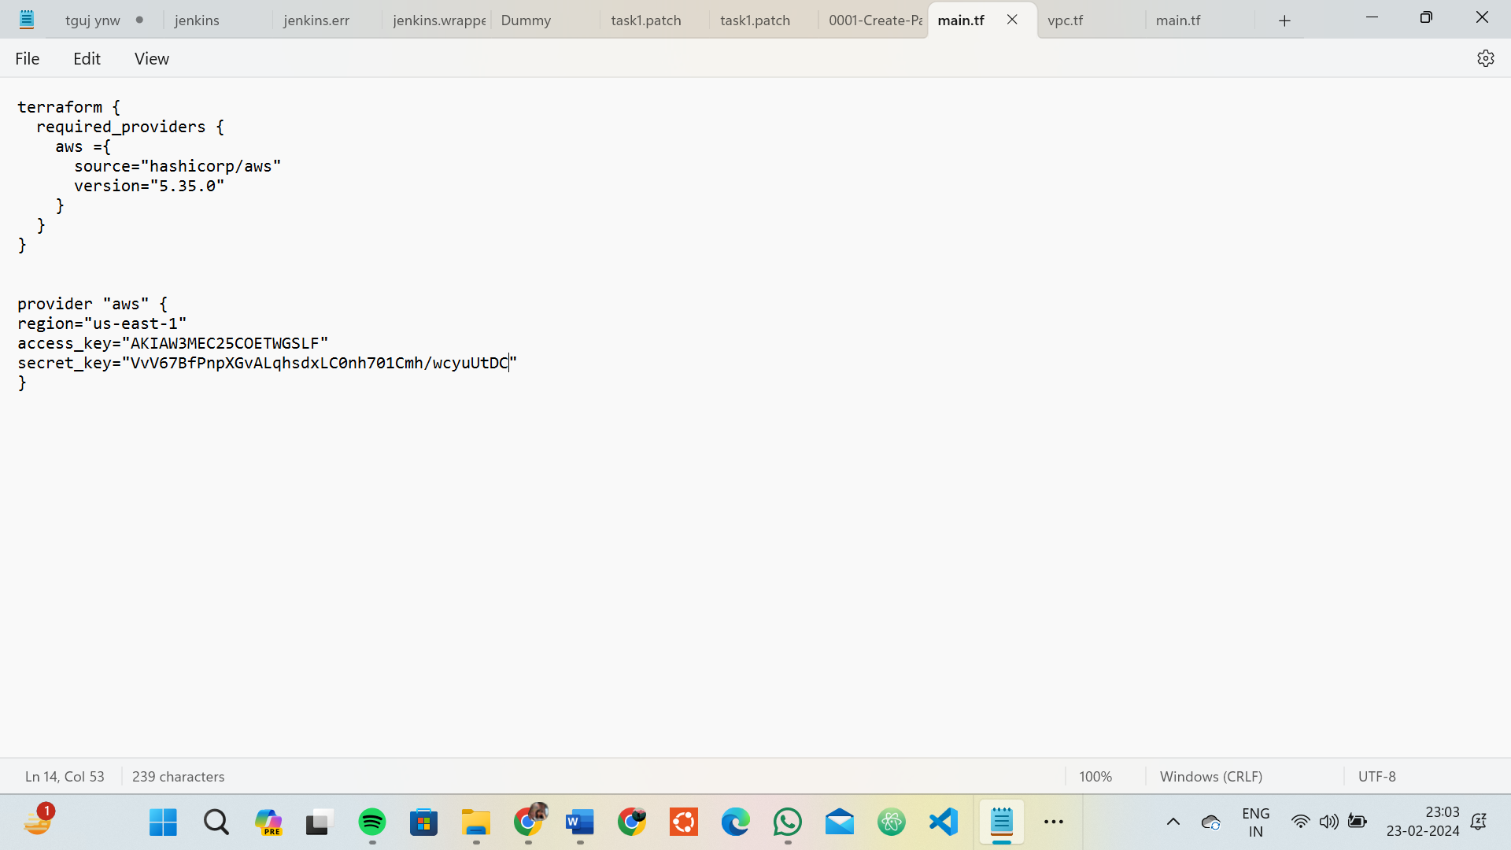

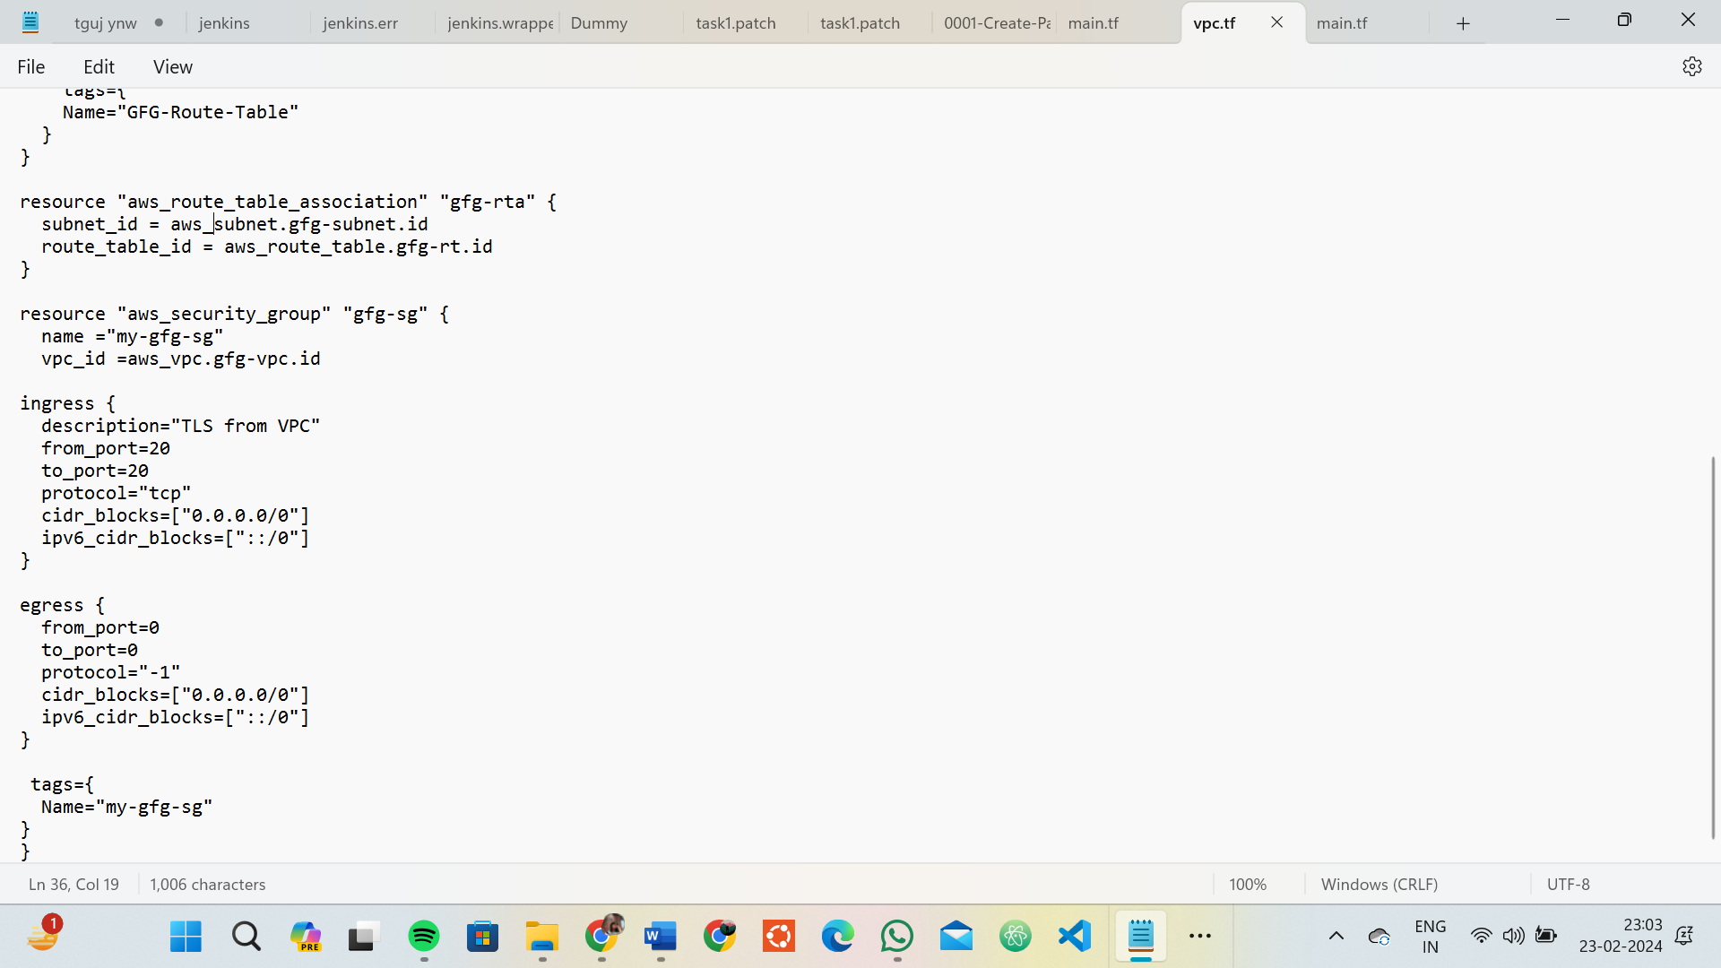

# Initialize and Apply:

* Run the following Terraform commands to initialize and apply the configuration:

**terraform init terraform apply**

* Terraform will prompt you to confirm the creation of the VPC and subnets. Type yes and press Enter.

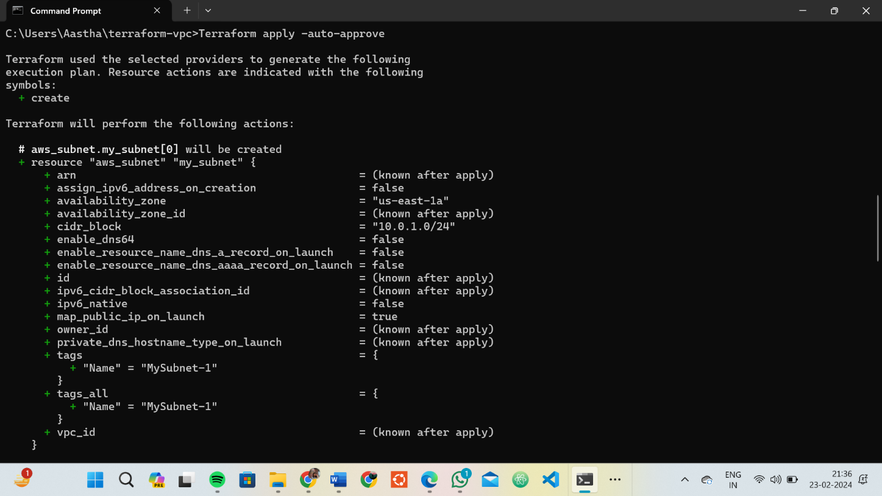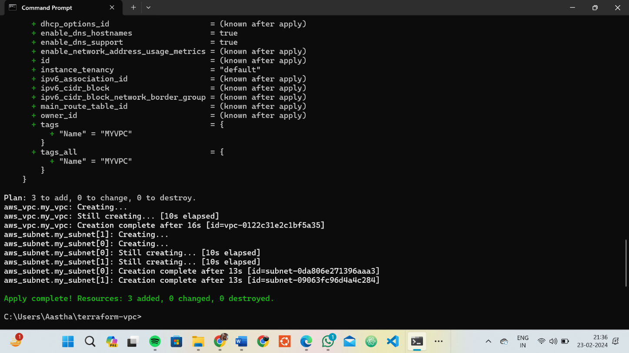

# Verify Resources in AWS Console:

* Log in to the AWS Management Console and navigate to the VPC service.
* Verify that the VPC and subnets with the specified names and settings have been created.

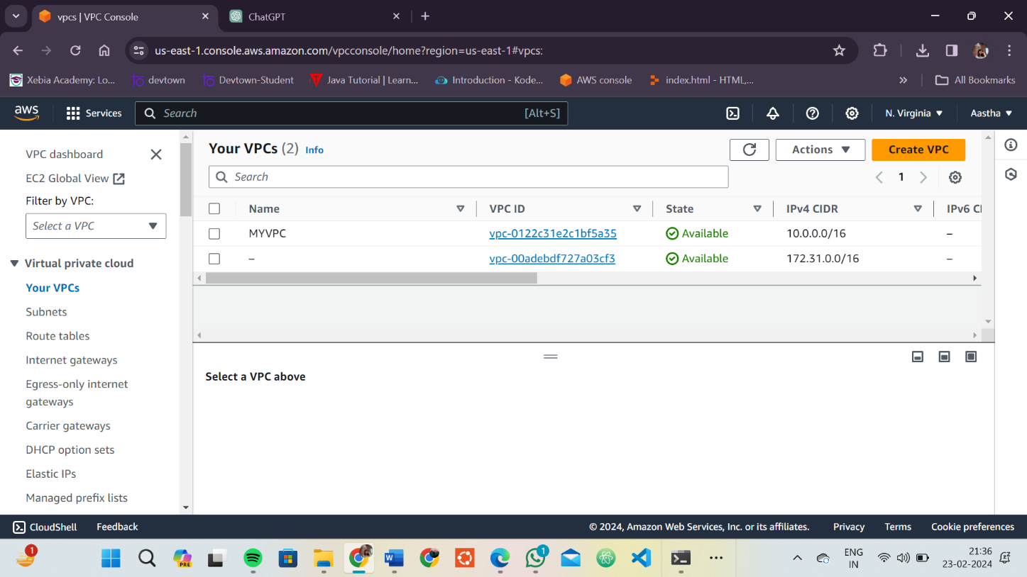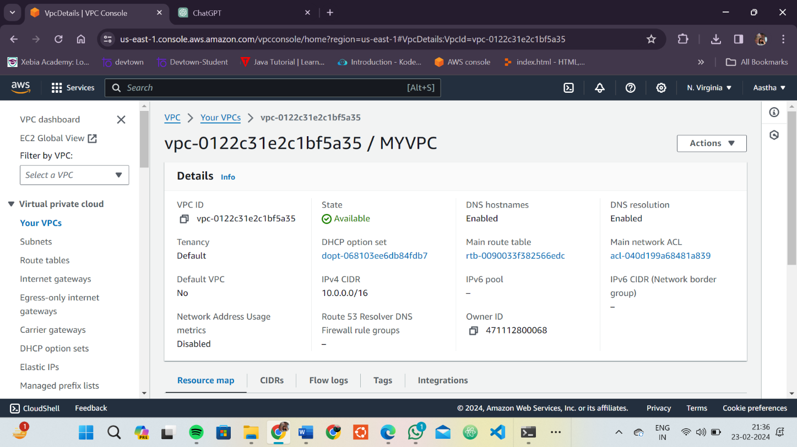

# Update VPC Configuration:

* If you want to modify the VPC configuration, update the main.tf file with the desired changes.
* Rerun the terraform apply command to apply the changes:

**terraform apply**

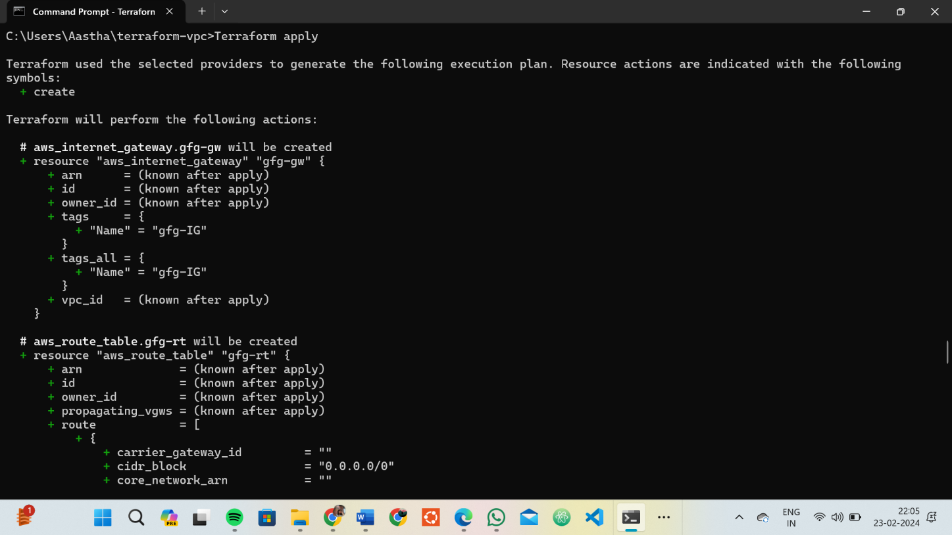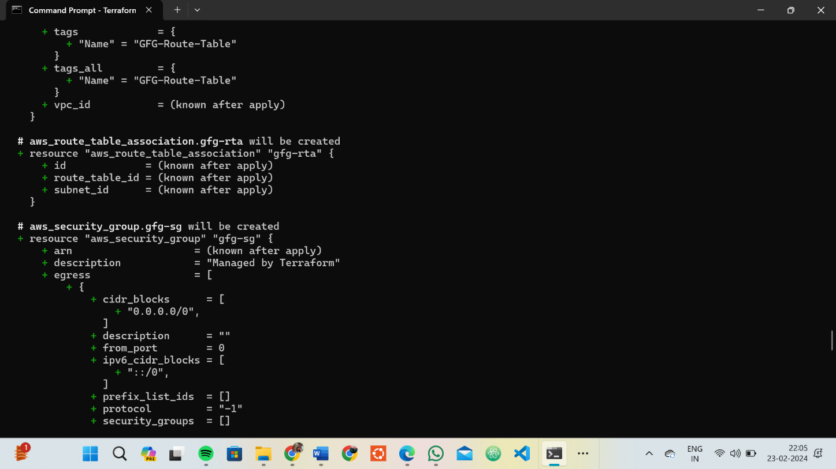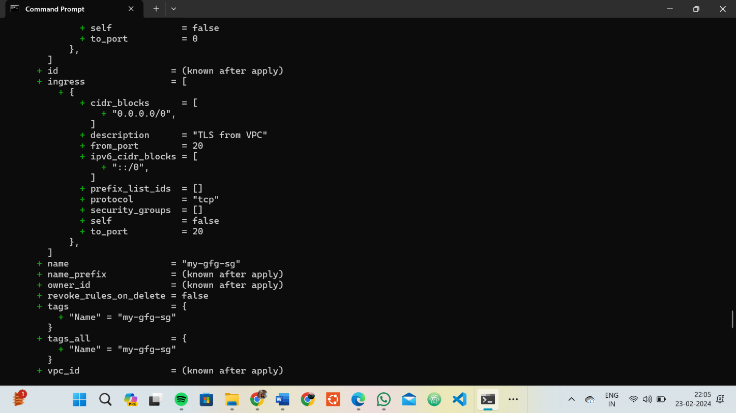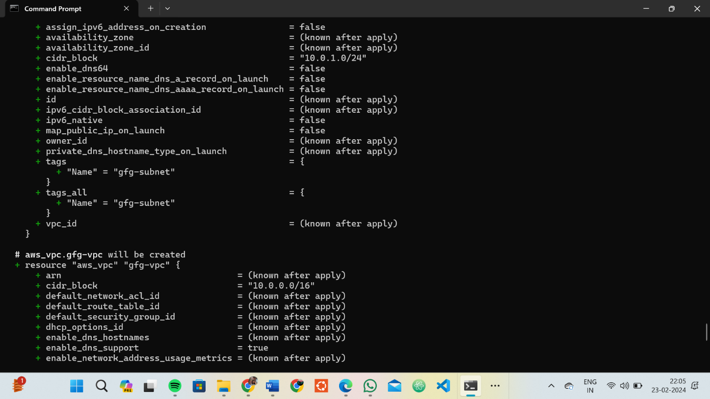

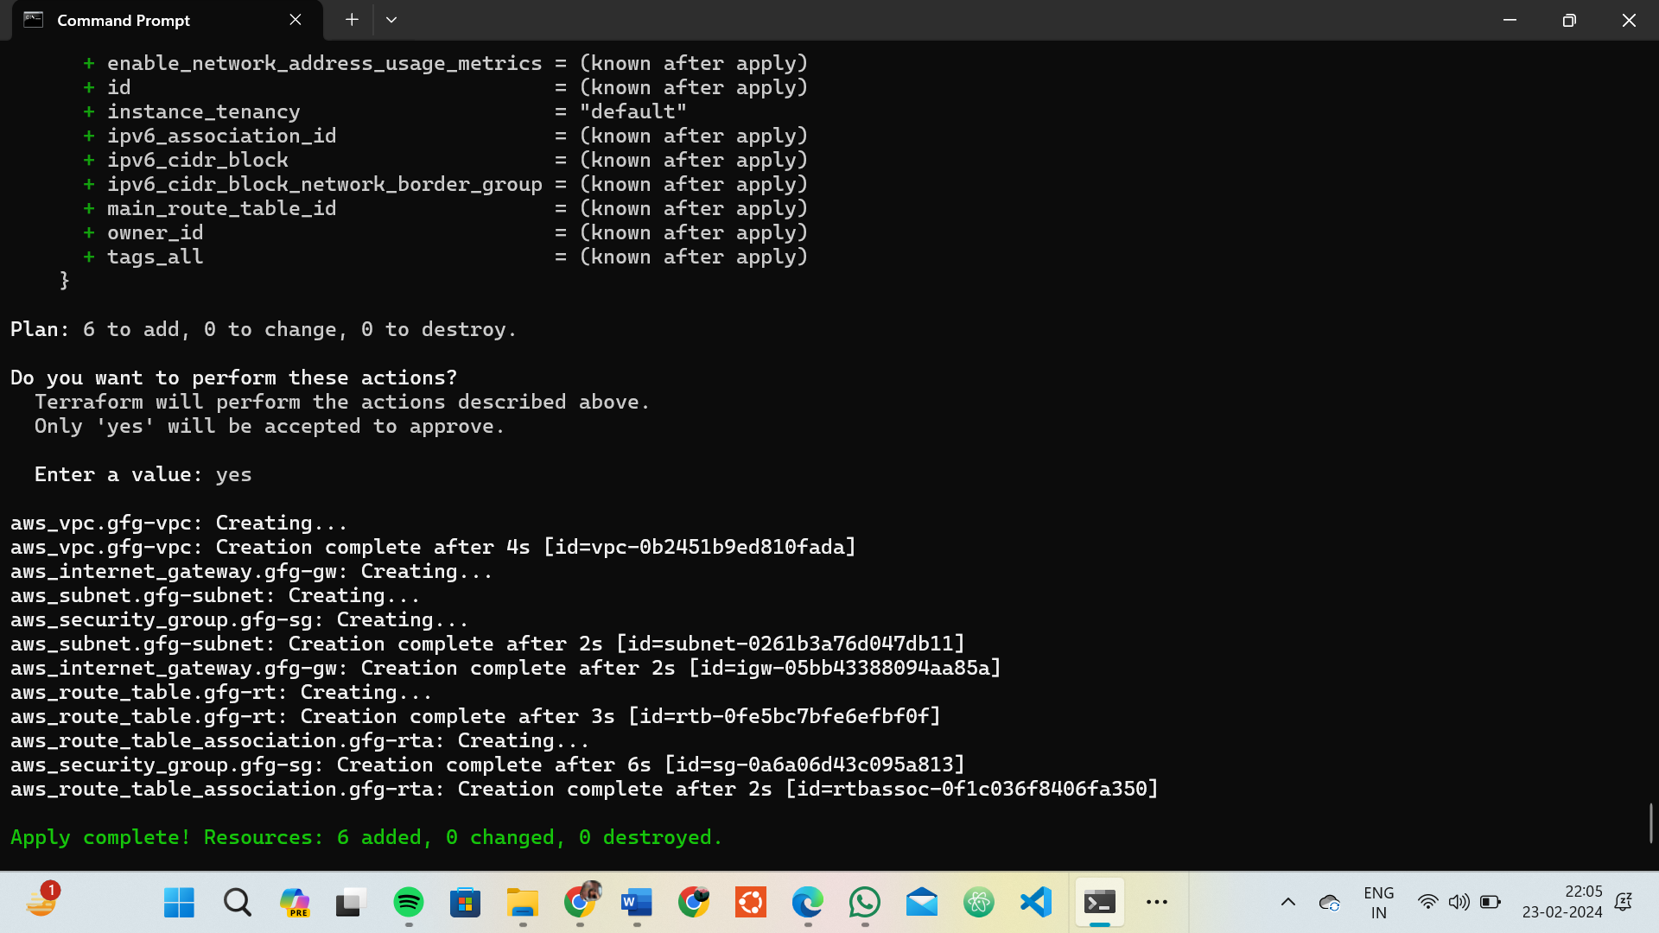

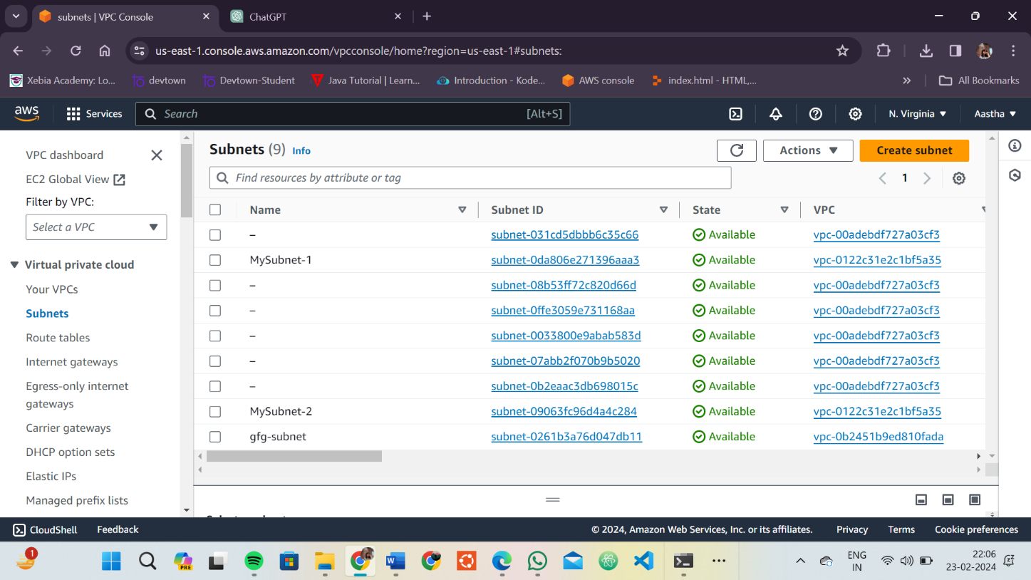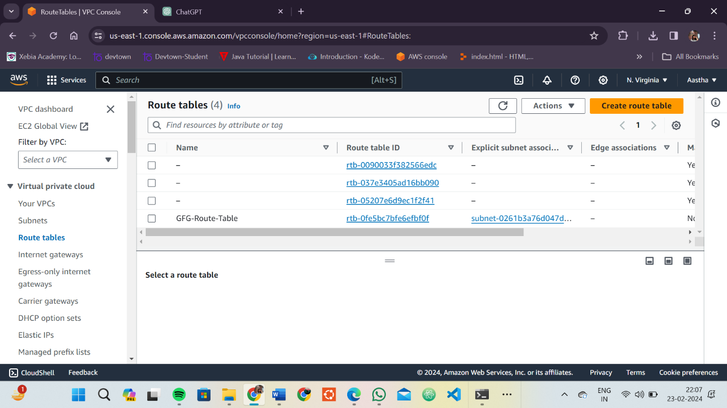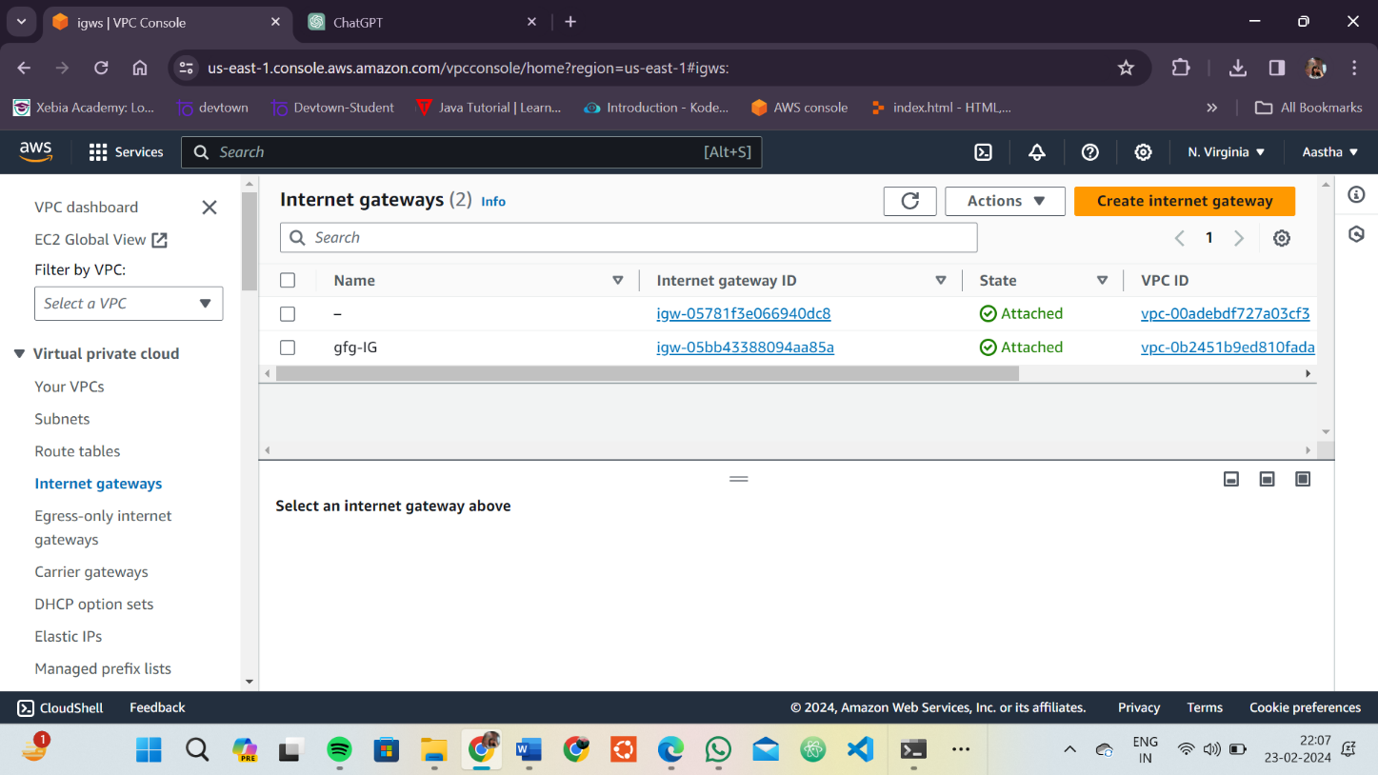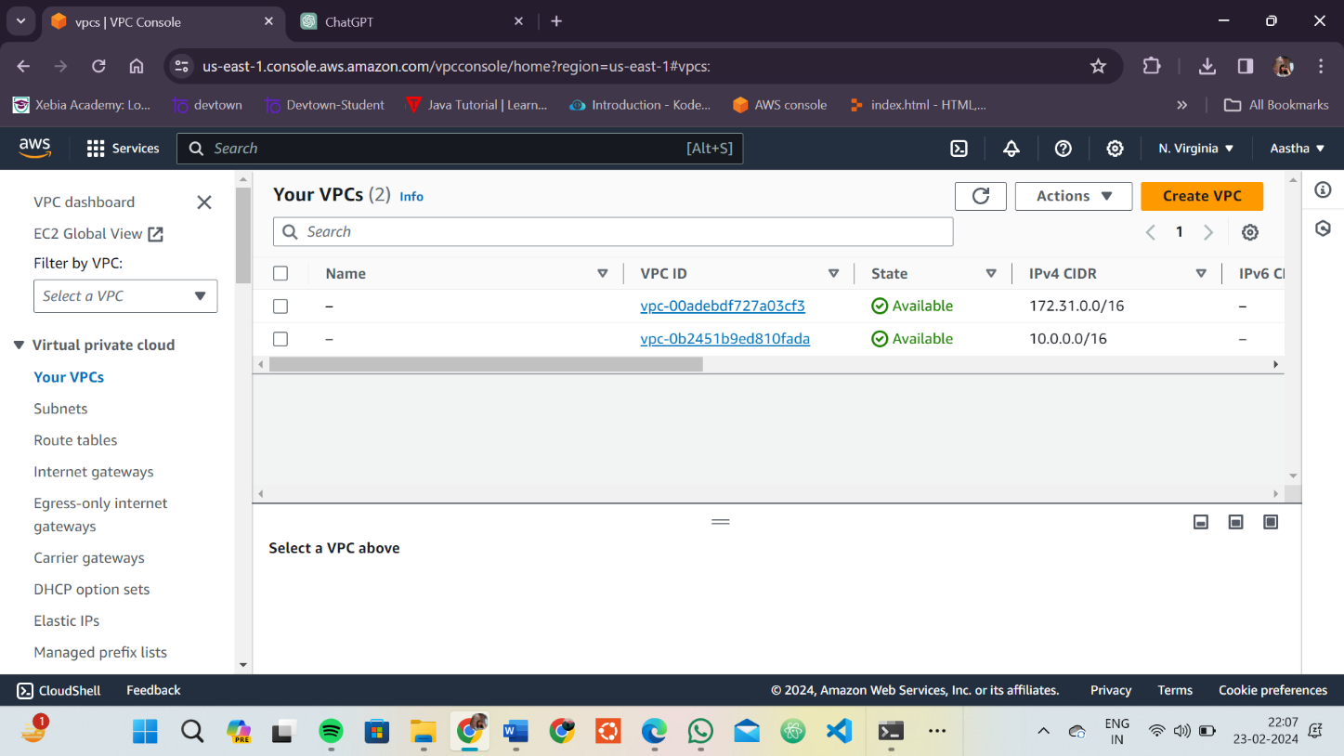

# Clean Up:

After testing, you can clean up the VPC and subnets:

**terraform destroy**

Confirm the destruction by typing yes.

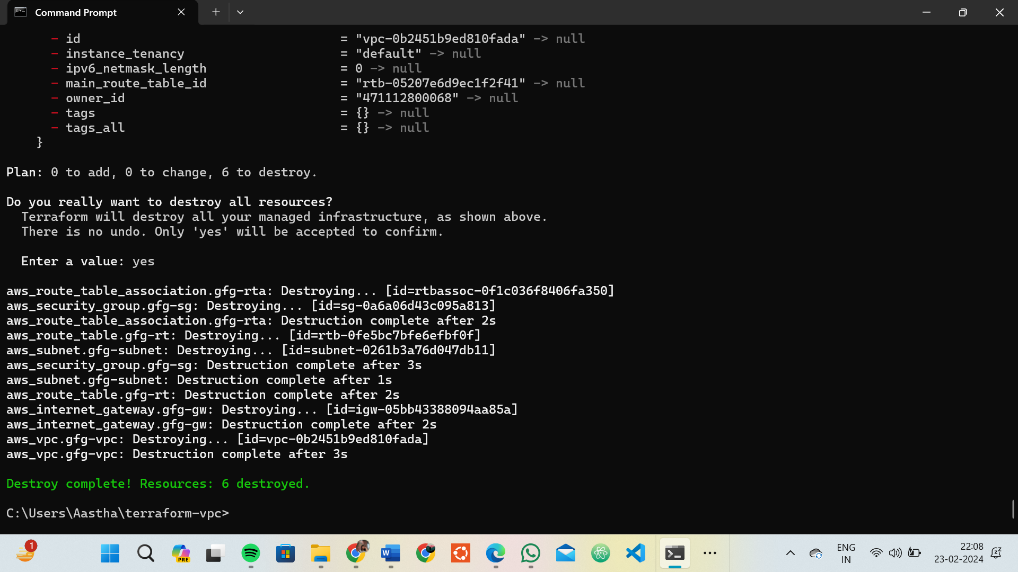

# Conclusion:

This lab exercise demonstrates how to create a basic Virtual Private Cloud (VPC) with subnets in AWS using Terraform. The example includes a simple VPC configuration with two subnets. Experiment with different CIDR blocks, settings, and additional AWS resources to customize your VPC.

# Lab Exercise 9– Creating Multiple EC2 Instances with for_each in Terraform

**Objective:**

Learn how to use for_each in Terraform to create multiple AWS EC2 instances with specific settings for each instance.

# Prerequisites:

* Terraform installed on your machine.
* AWS CLI configured with the necessary credentials.

# Steps:

1. **Create a Terraform Directory:**

**mkdir terraform-ec2-for-each cd terraform-ec2-for-each**

* + Create Terraform Configuration Files:
  + Create a file named main.tf:

## # main.tf

**provider "aws" { region = "ap-south-1"**

**}**

**variable "instances" {**

**description = "Map of EC2 instances with settings" default = {**

**"instance1" = {**

**ami**

**= "ami-0c55b159cbfafe1f0"**

**instance_type = "t2.micro"**

**},**

**"instance2" = {**

**ami = "ami-0123456789abcdef0" instance_type = "t2. micro "**

**},**

**"instance3" = {**

**ami = "ami-9876543210fedcba0" instance_type = "t2. micro "**

**}**

**}**

**}**

**resource "aws_instance" "ec2_instances" { for_each = var.instances**

**ami = var.instances[each.key].ami**

**instance_type = var.instances[each.key].instance_type tags = {**

**Name = "EC2-Instance-${each.key}"**

**}**

**}**

* + Replace "your-key-pair-name" and "your-subnet-id" with your actual key pair name and subnet ID.
  + In this configuration, we define a variable instances as a map containing settings for each EC2 instance. The aws_instance resource is then used with for_each to create instances based on the map.

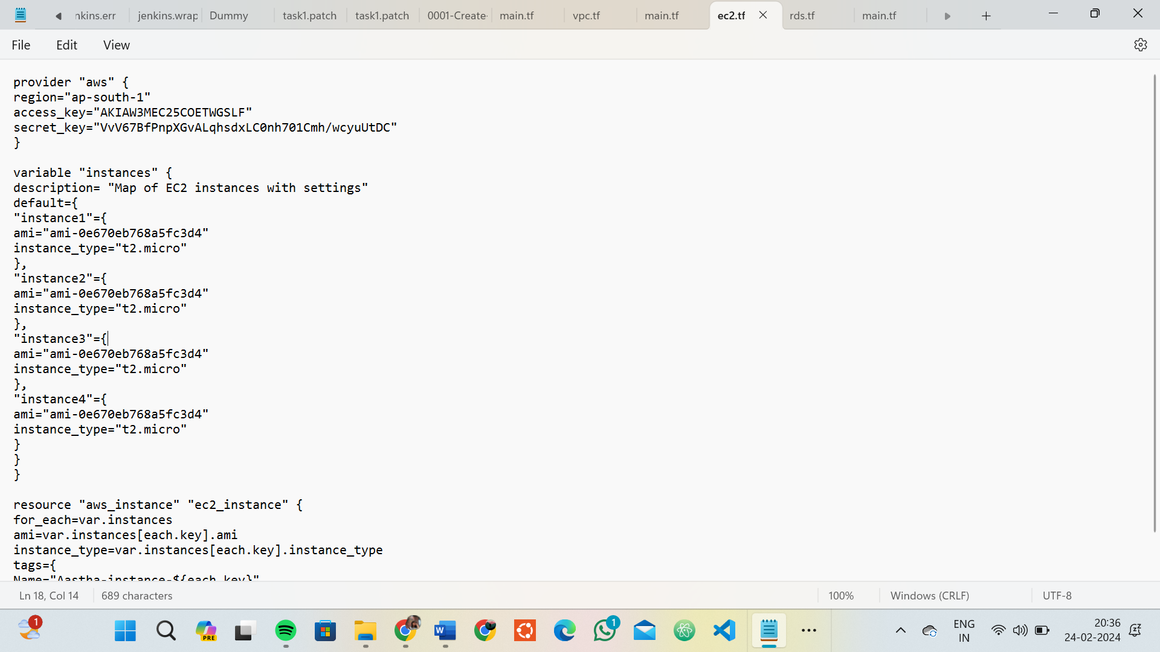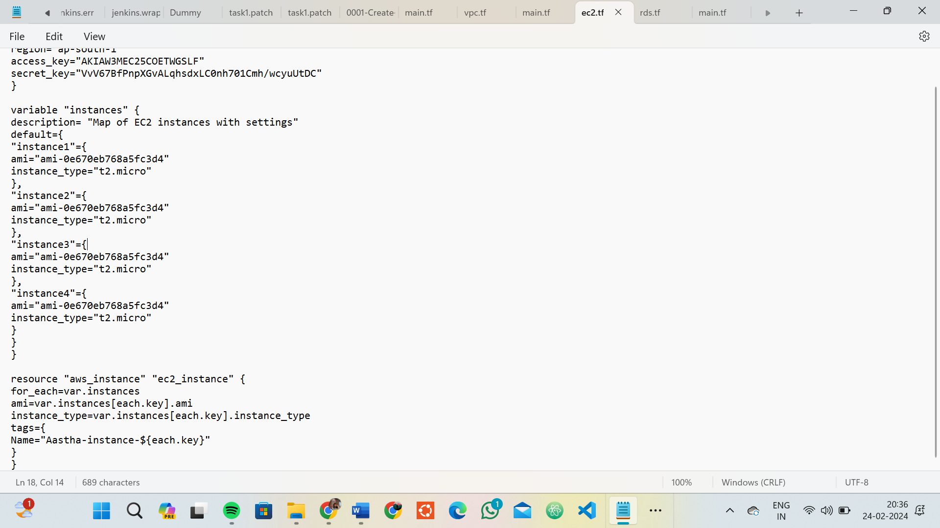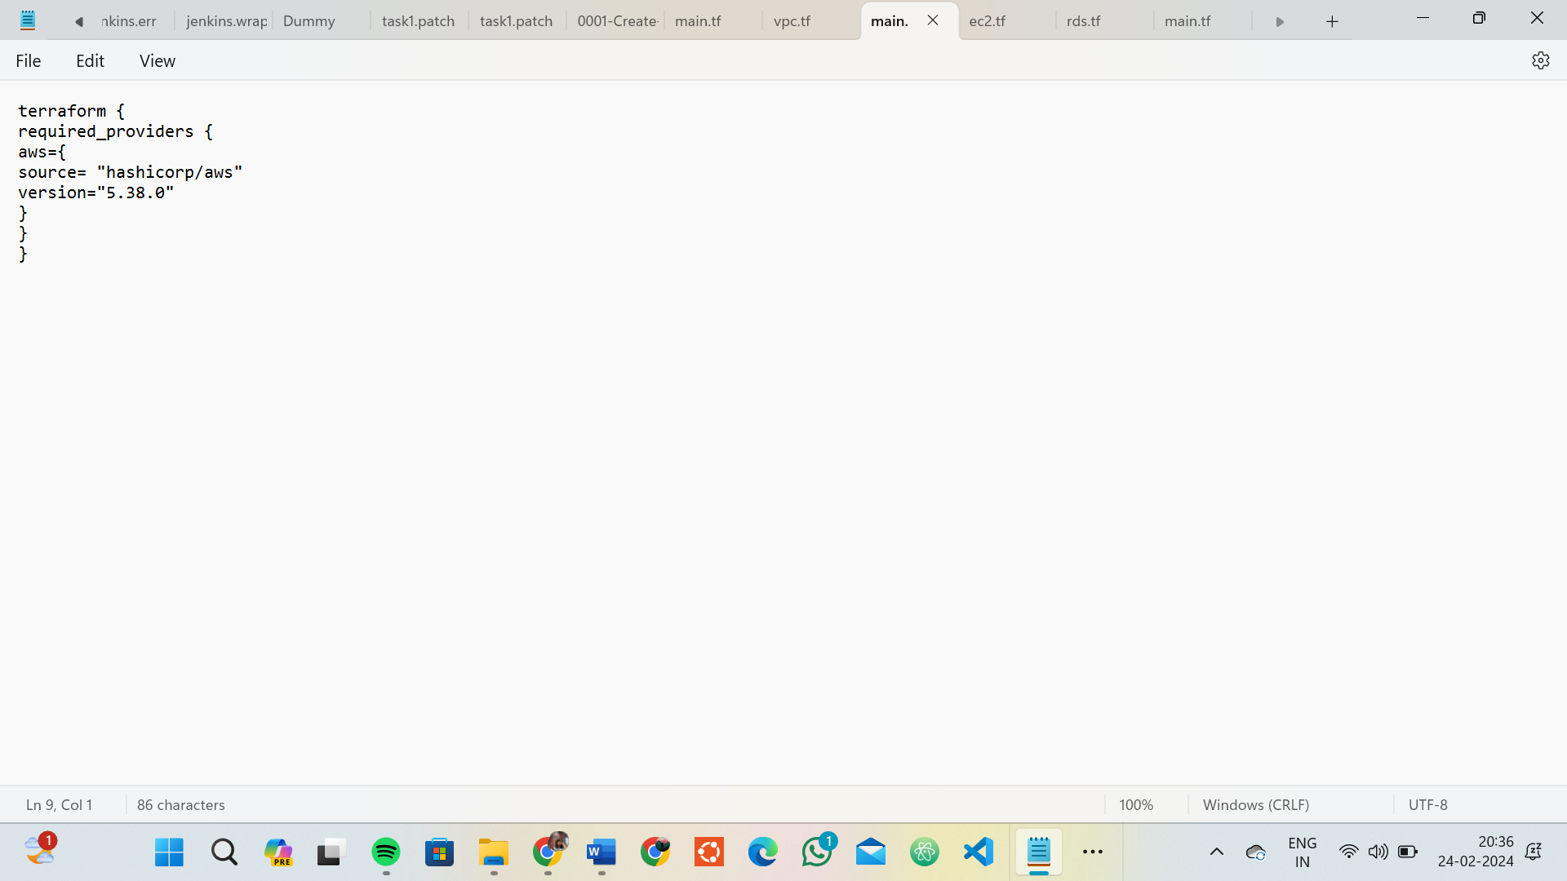

# Initialize and Apply:

* + Run the following Terraform commands to initialize and apply the configuration:

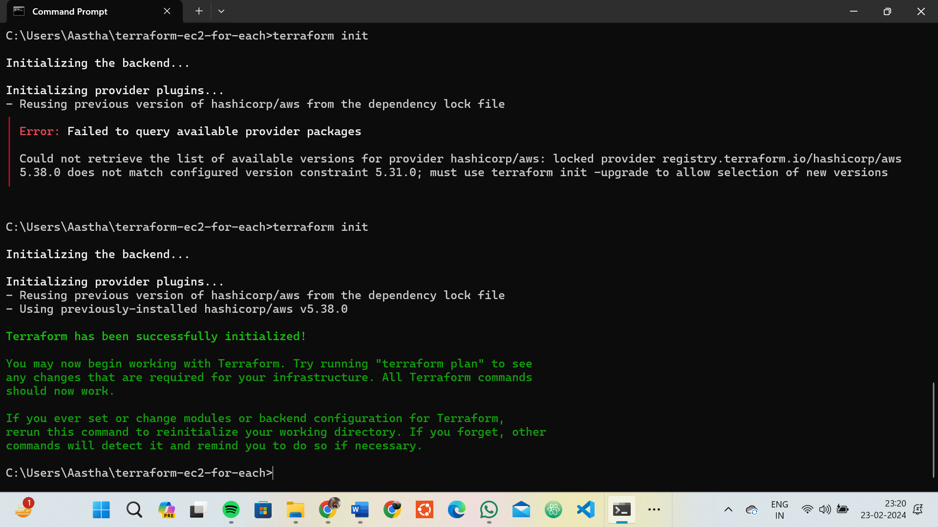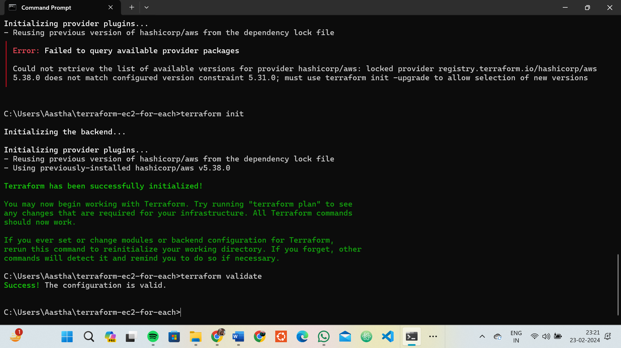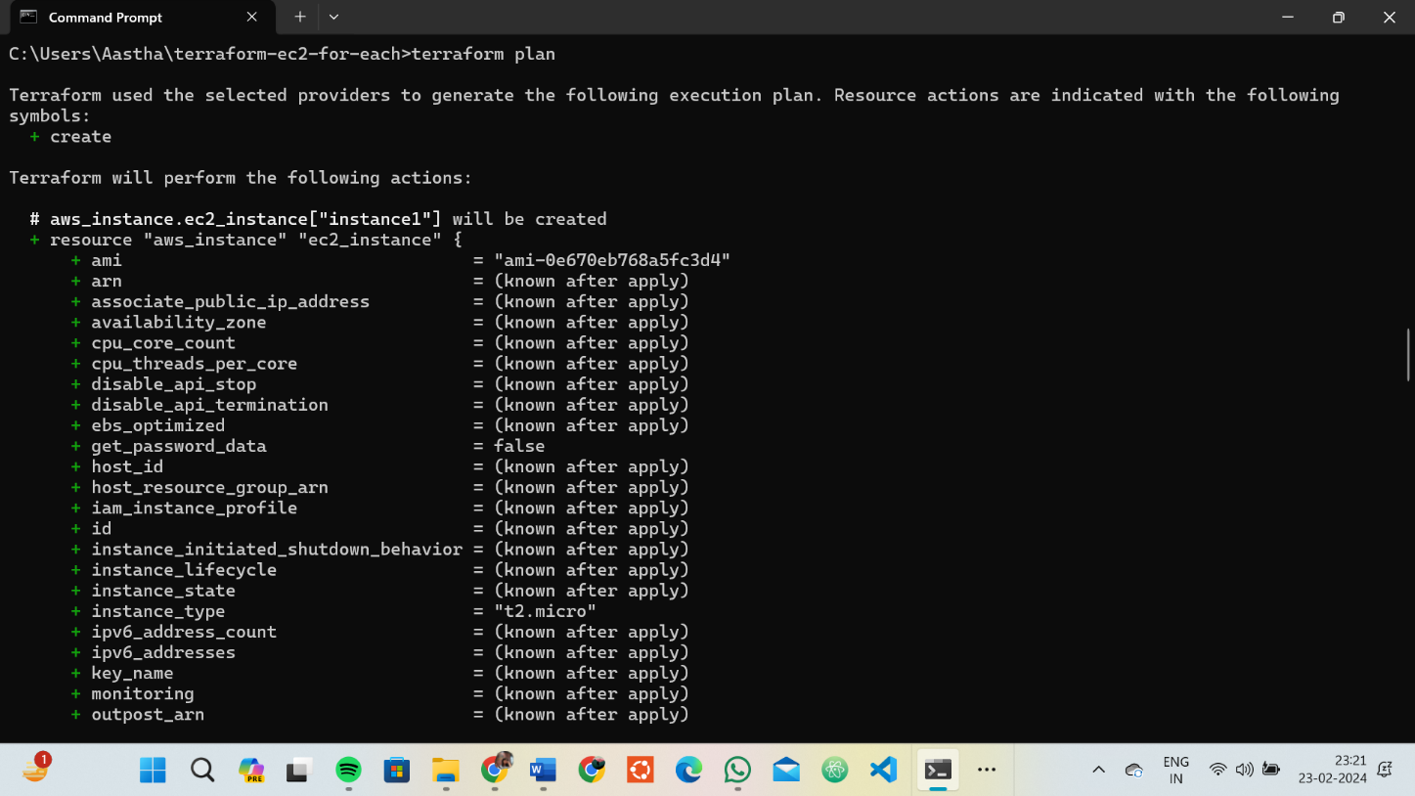

**terraform init terraform apply**

* + Terraform will prompt you to confirm the creation of EC2 instances. Type yes and press Enter.

# Verify Instances in AWS Console:

* + Log in to the AWS Management Console and navigate to the EC2 service.
  + Verify that the specified EC2 instances with the specified names and settings have been created.

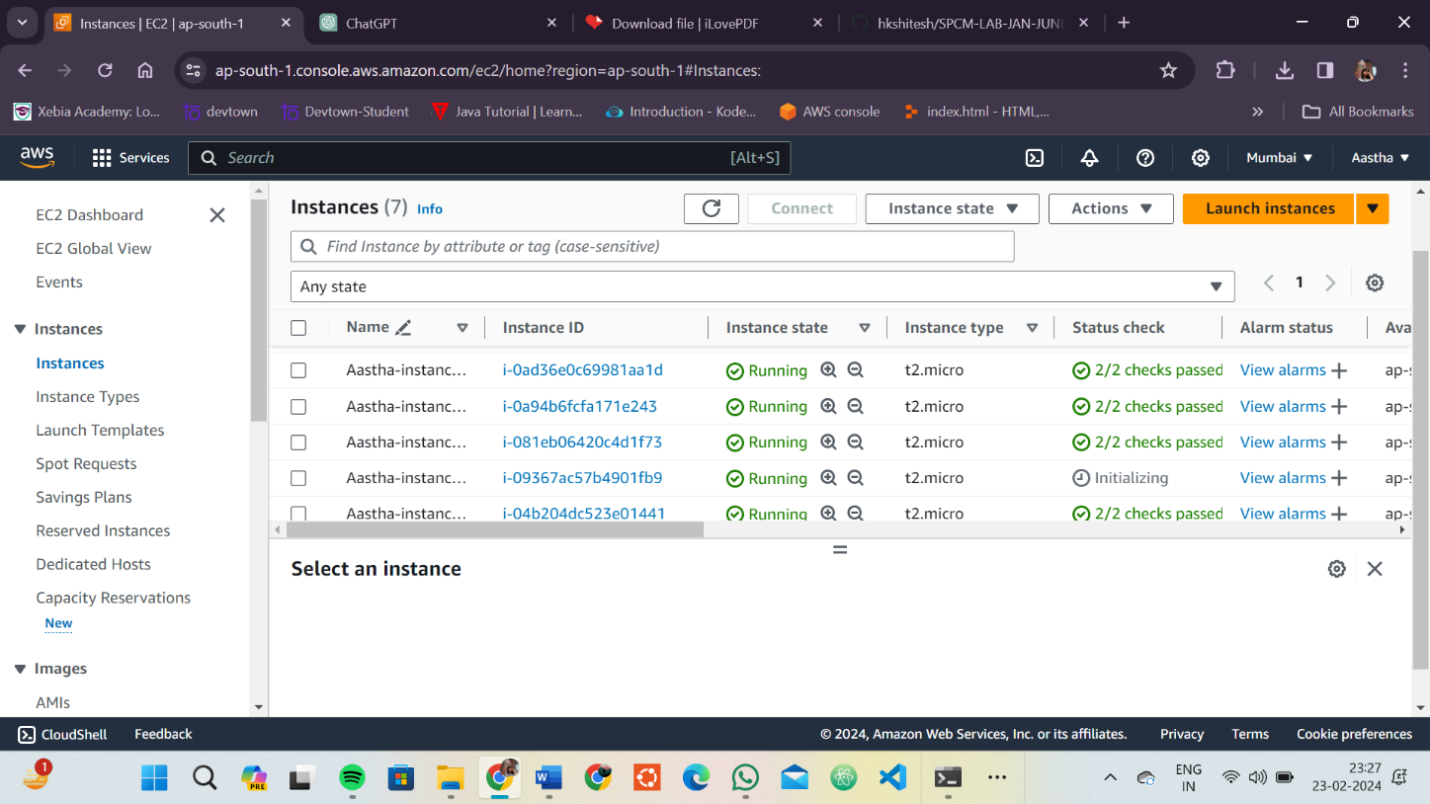

# Update Instance Configuration:

* + If you want to modify the EC2 instance configuration, update the main.tf file with the desired changes.
  + Rerun the terraform apply command to apply the changes:

**terraform apply**

# 

# Clean Up:

* + After testing, you can clean up the EC2 instances:

**terraform destroy**

* + Confirm the destruction by typing yes. 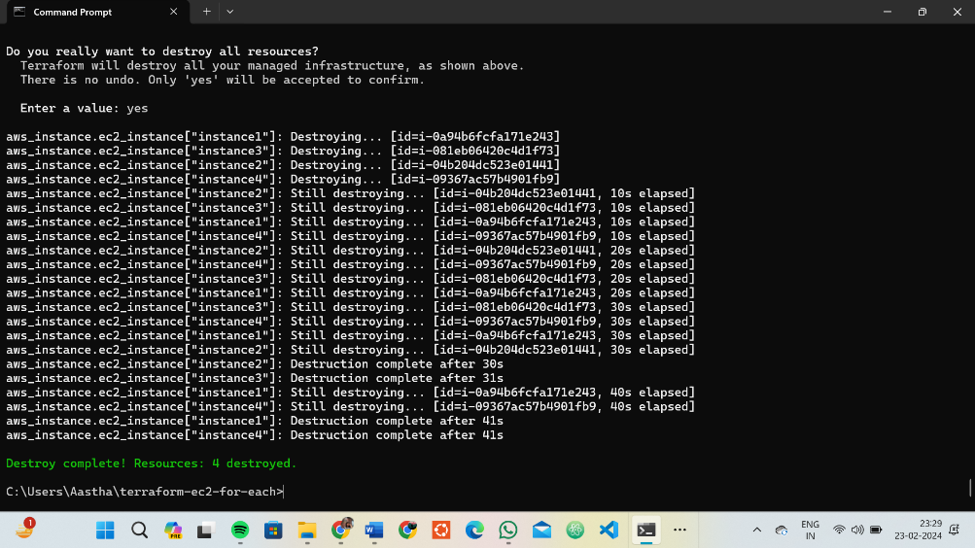

# Conclusion:

This lab exercise demonstrates how to use the for_each construct in Terraform to create multiple AWS EC2 instances with specific settings for each instance. The use of a map allows you to define and manage settings for each instance individually. Experiment with different instance types, AMIs, and settings in the main.tf file to observe how Terraform provisions resources based on your configuration.

# Lab Exercise 10– Creating an AWS RDS Instance in Terraform

**Objective:**

Learn how to use Terraform to create an AWS RDS instance.

# Prerequisites:

* Terraform installed on your machine.
* AWS CLI configured with the necessary credentials.

# Steps:

1. **Create a Terraform Directory:**

**mkdir terraform-rds cd terraform-rds**

# Create Terraform Configuration Files:

Create a file named main.tf:

## # main.tf

**provider "aws" { region = "us-east-1"**

**}**

**resource "aws_db_instance" "My-RDS" { allocated_storage = 10**

**db_name = "upesdb" engine = "mysql"**

**engine_version = "5.7" instance_class = "db.t2.micro" username = "admin" password = "Hitesh111"**

**parameter_group_name = "default.mysql5.7" skip_final_snapshot = true**

**}**

* Replace "YourPassword123" with a secure password and "your-security-group-id" with your actual security group ID.
* In this configuration, we define an AWS RDS instance with specific settings, such as engine type, instance class, and security group.

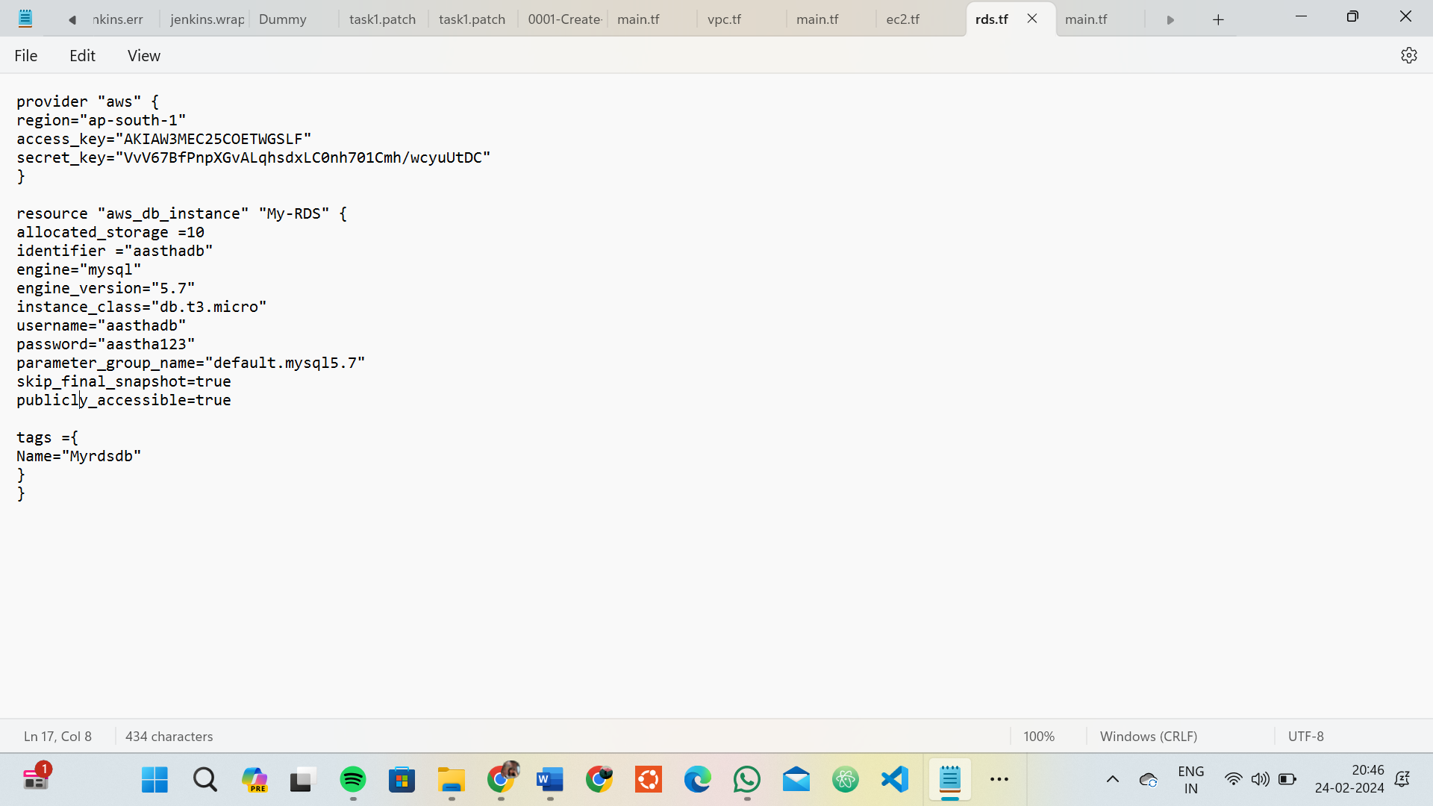

# Initialize and Apply:

* Run the following Terraform commands to initialize and apply the configuration:

**terraform init terraform apply**

* Terraform will prompt you to confirm the creation of the RDS instance. Type yes and press Enter.

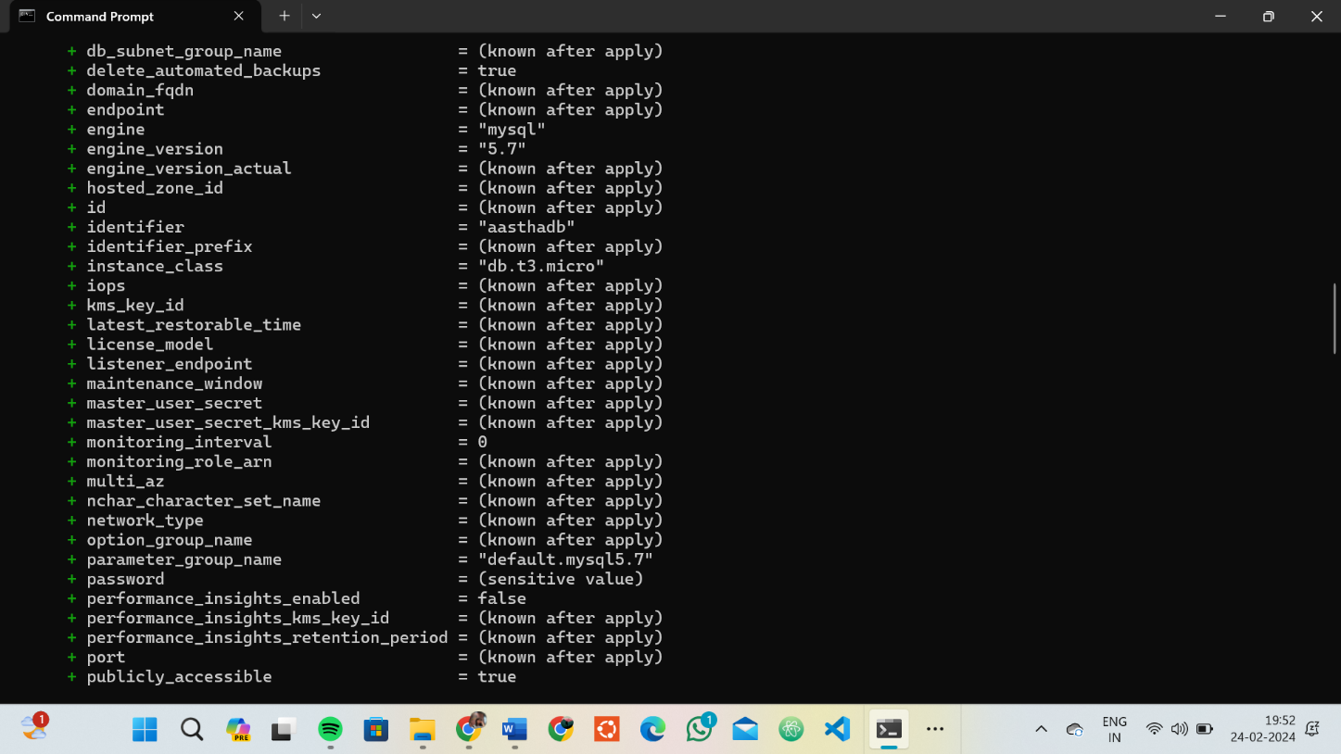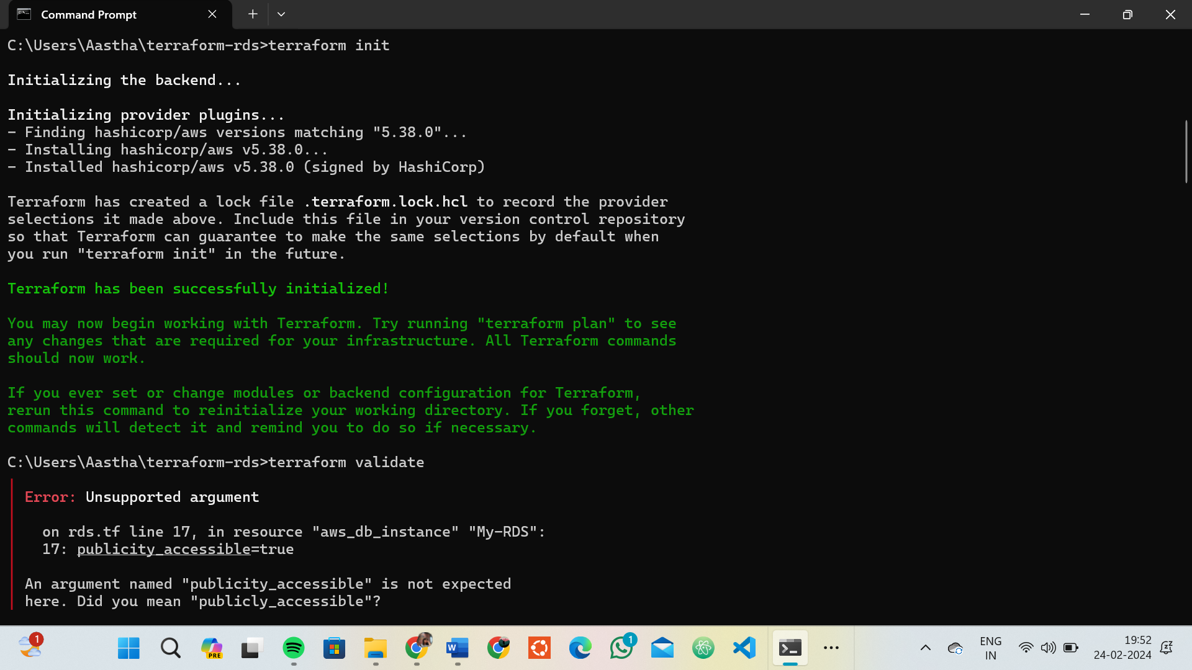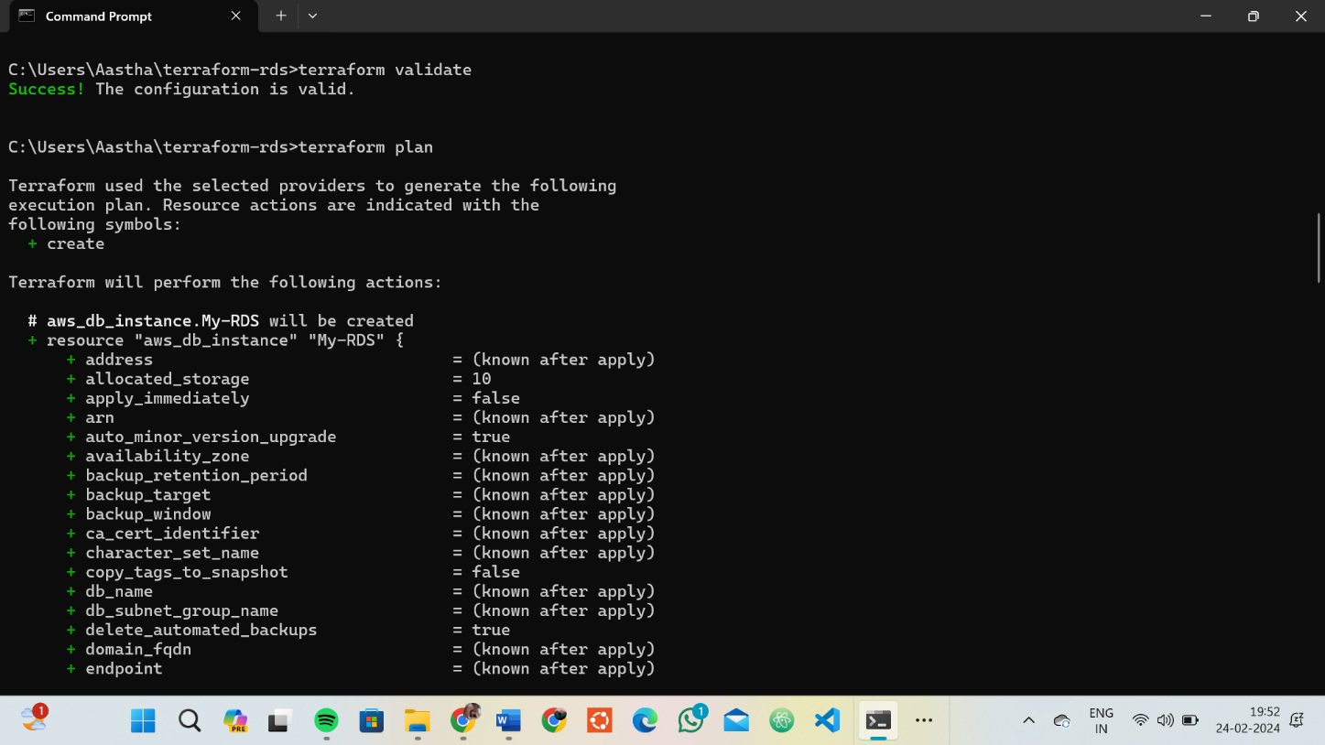

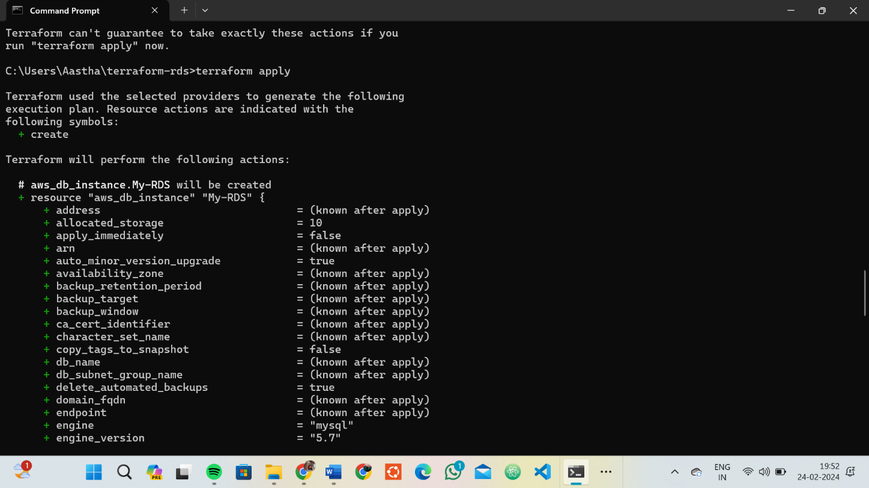

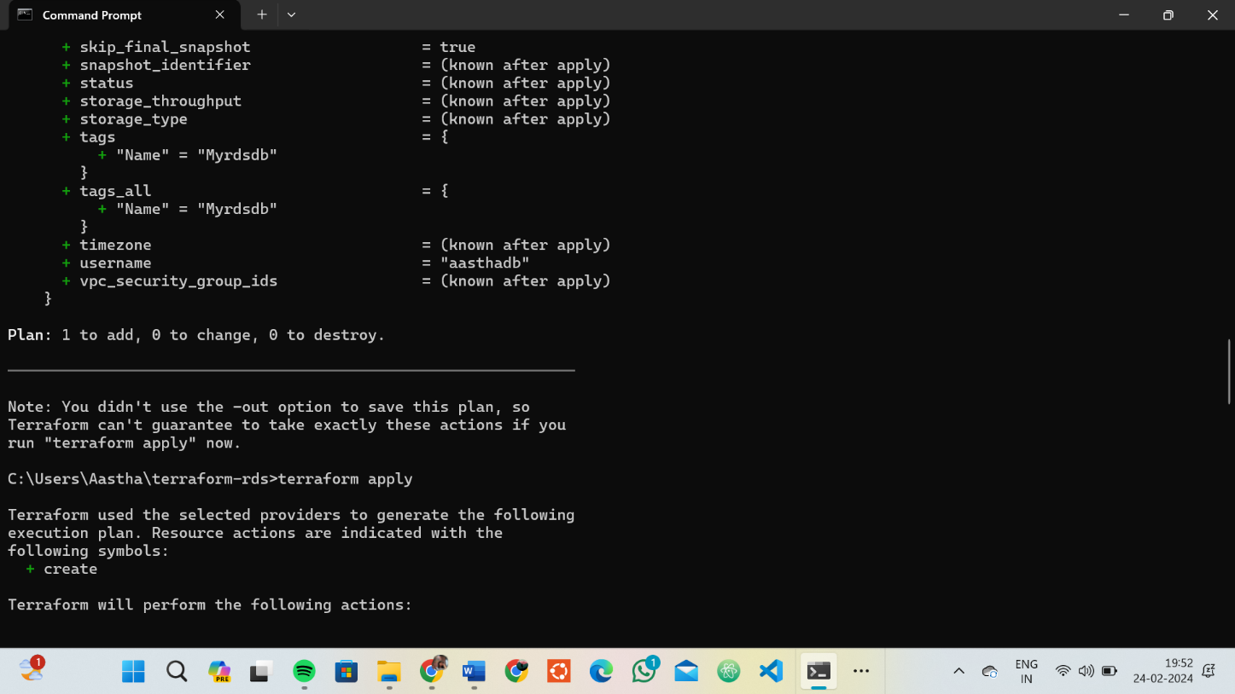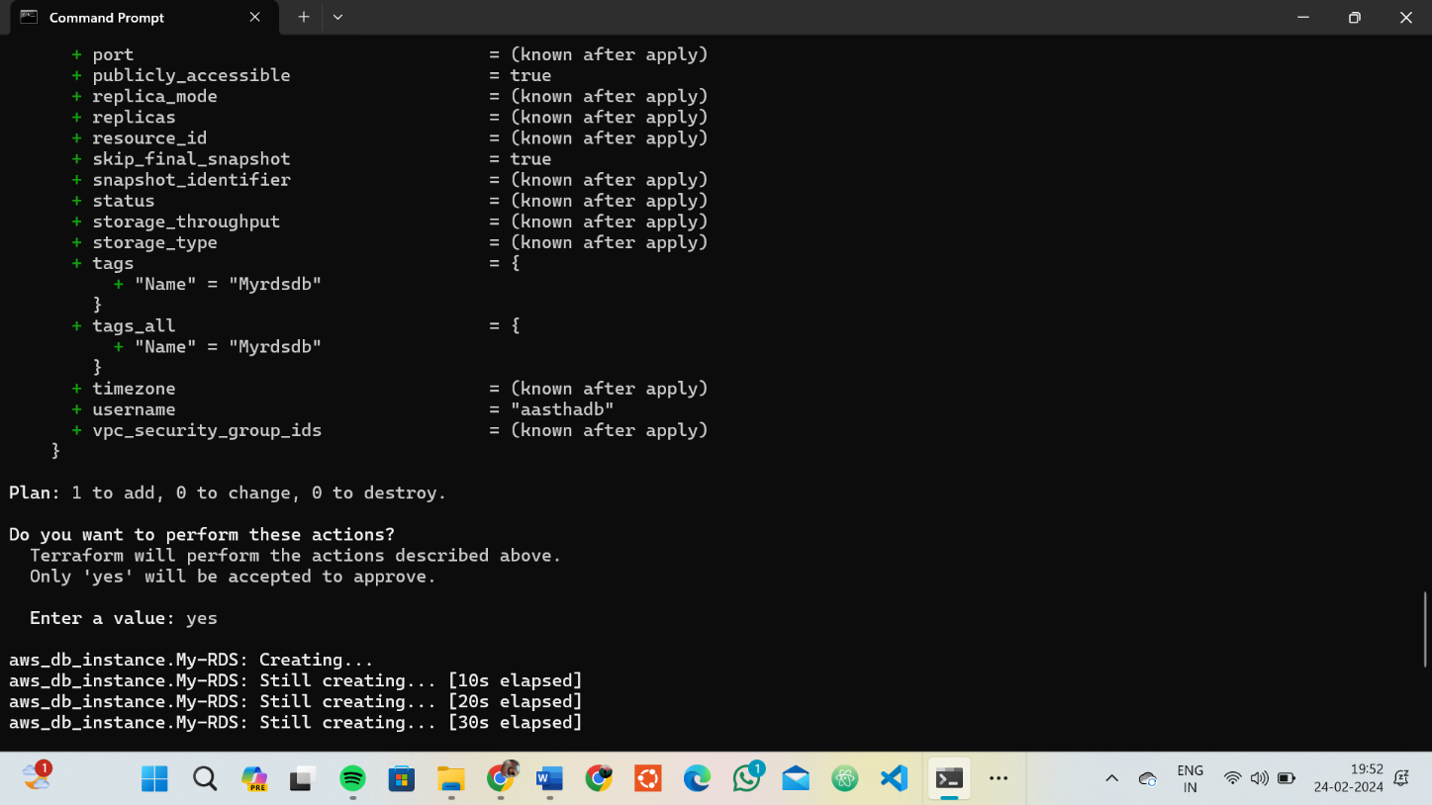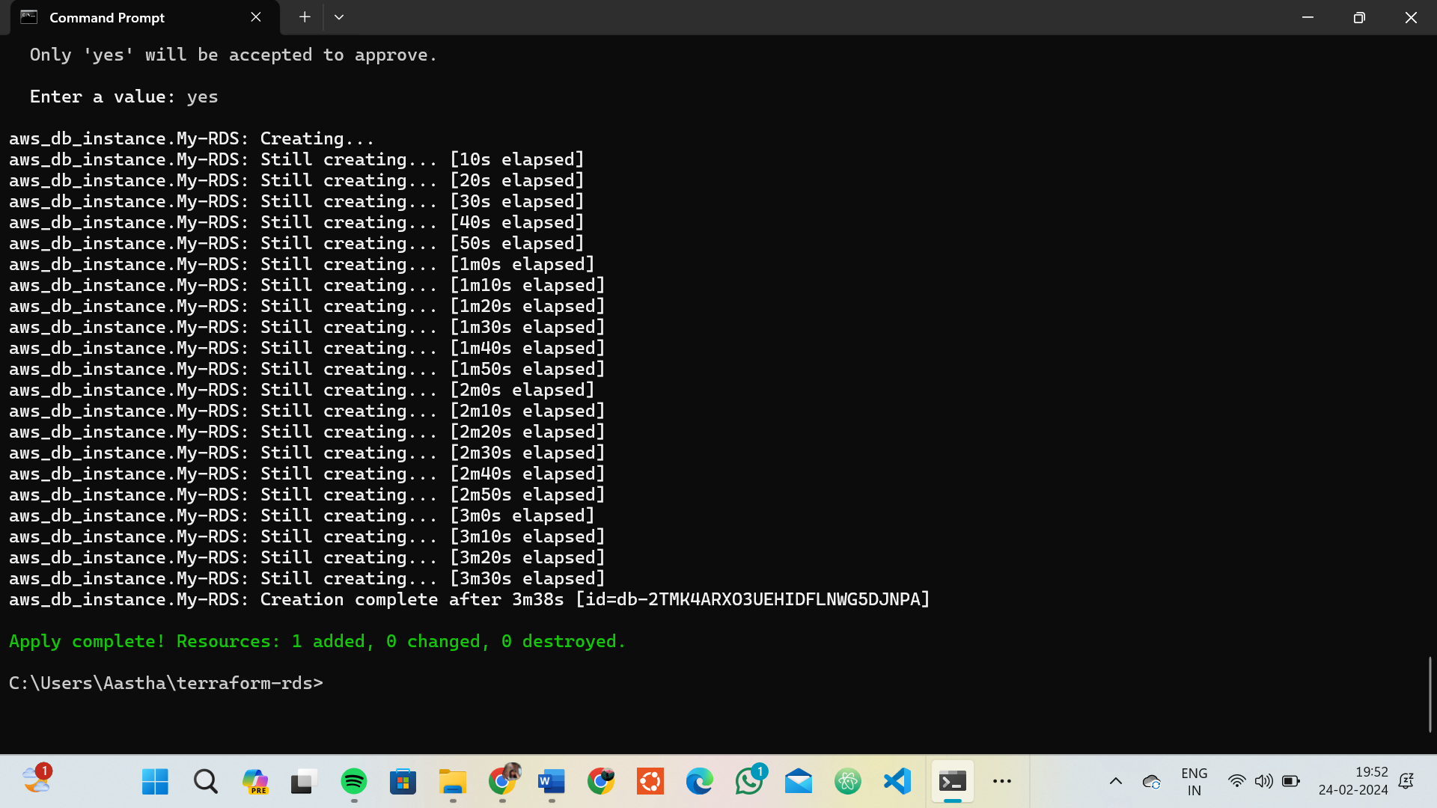

# Verify RDS Instance in AWS Console:

* Log in to the AWS Management Console and navigate to the RDS service.
* Verify that the specified RDS instance with the specified settings has been created.

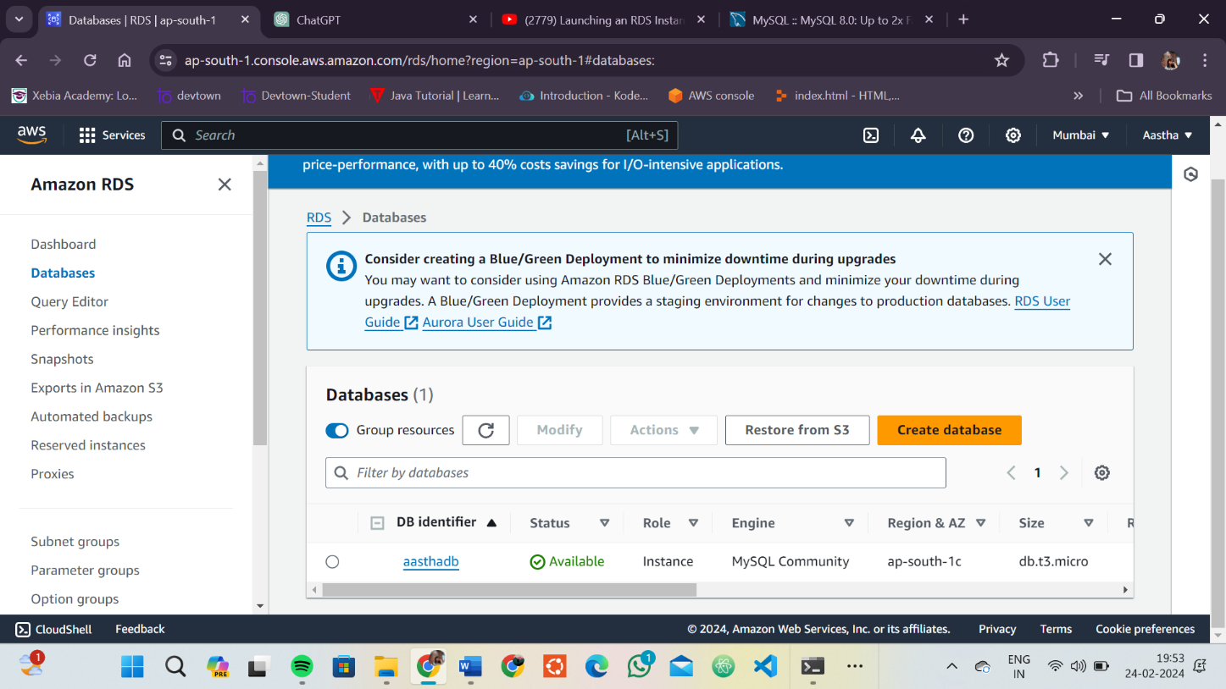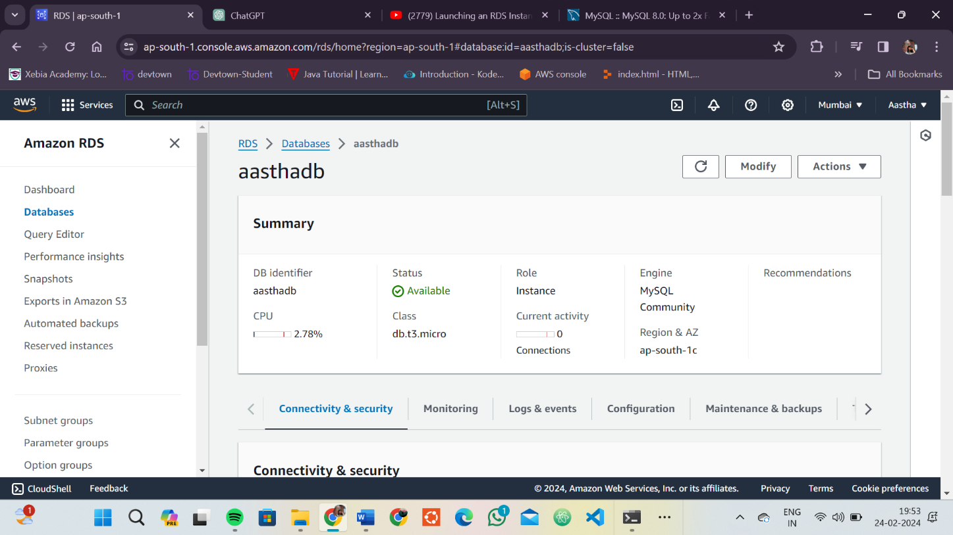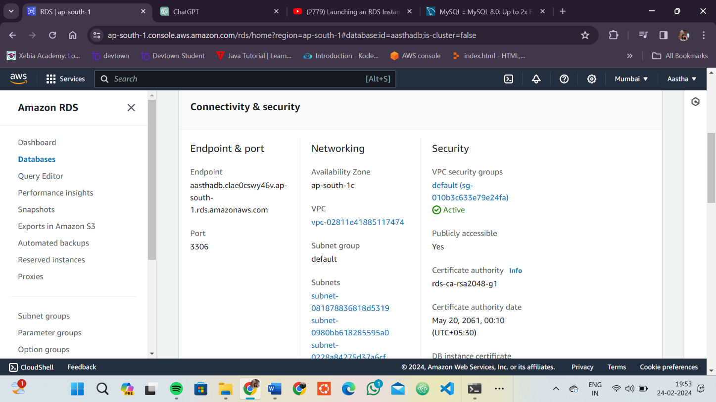

# Update RDS Configuration:

* If you want to modify the RDS instance configuration, update the main.tf file with the desired changes.
* Rerun the terraform apply command to apply the changes:

**terraform apply**

# Clean Up:

After testing, you can clean up the RDS instance:

**terraform destroy**

Confirm the destruction by typing yes.

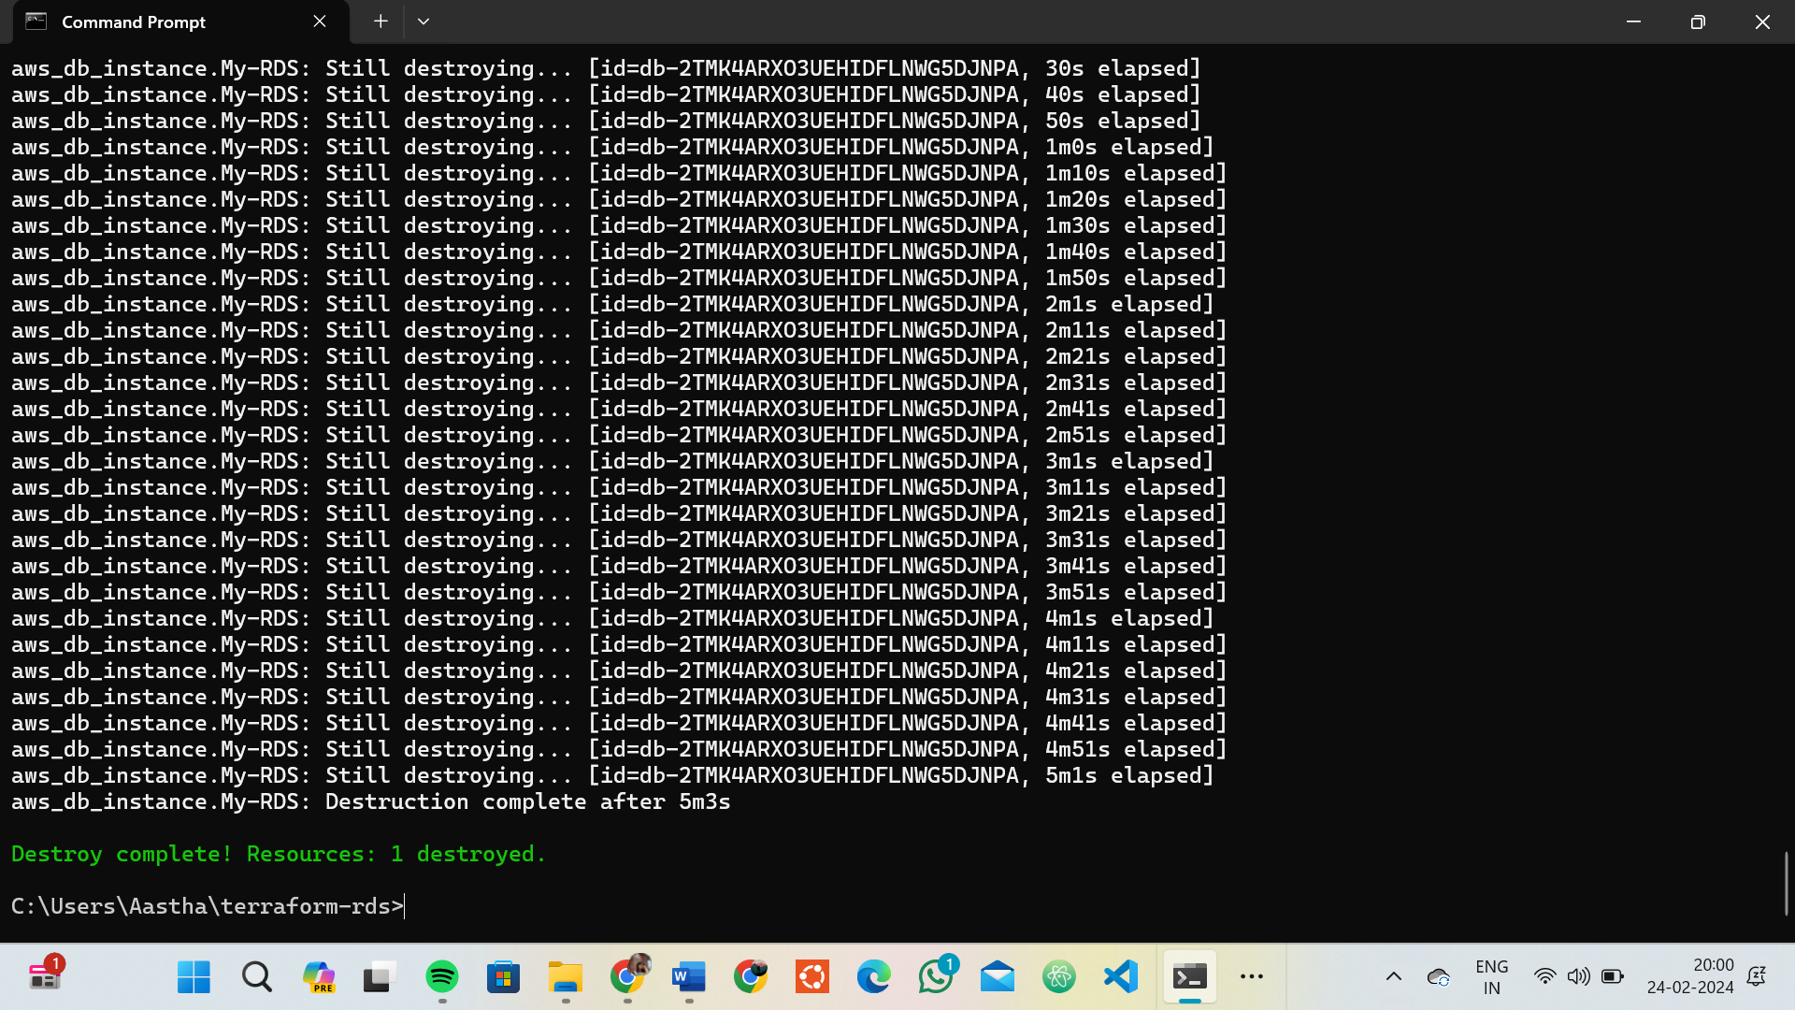

# Conclusion:

This lab exercise demonstrates how to use Terraform to create an AWS RDS instance. You learned how to define RDS settings, initialize and apply the Terraform configuration, and verify the creation of the RDS instance in the AWS Management Console. Experiment with different RDS setting.